**LAB EXPERIMENTS OUTPUT / SCREEN SHOTS**

COURSE CODE : CSA1503

COURSE : CLOUD COMPUTING AND BIG DATA ANALYTICS FOR INTERNET OF THINGS

# SLOT : D

**NAME : ANSHUL JOLLY JOSHI**

**REG. NO: 192211973**

# SL.No: 1

**EX. NO ; 1 CREATE A SIMPLE CLOUD SOFTWARE APPLICATION AND PROVIDE IT AS A SERVICE USING ANY CLOUD SERVICE PROVIDER TODEMONSTRATE SOFTWARE AS A SERVICE (SAAS).**

**DATE OF EXPERIMENT:16-09-2024**

**AIM ;** To create a simple cloud software application and provide it as a service using any cloud service provider to demonstrate software as a service (saas).

**SCREEN SHOTS AND OUTPUT:**

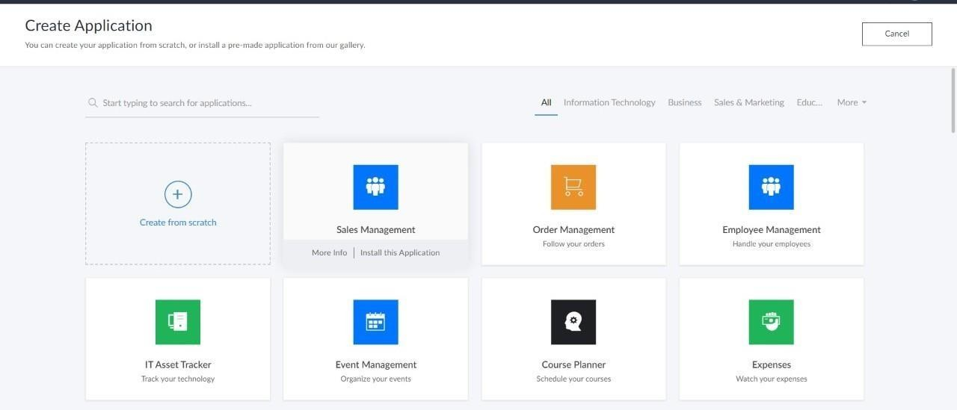

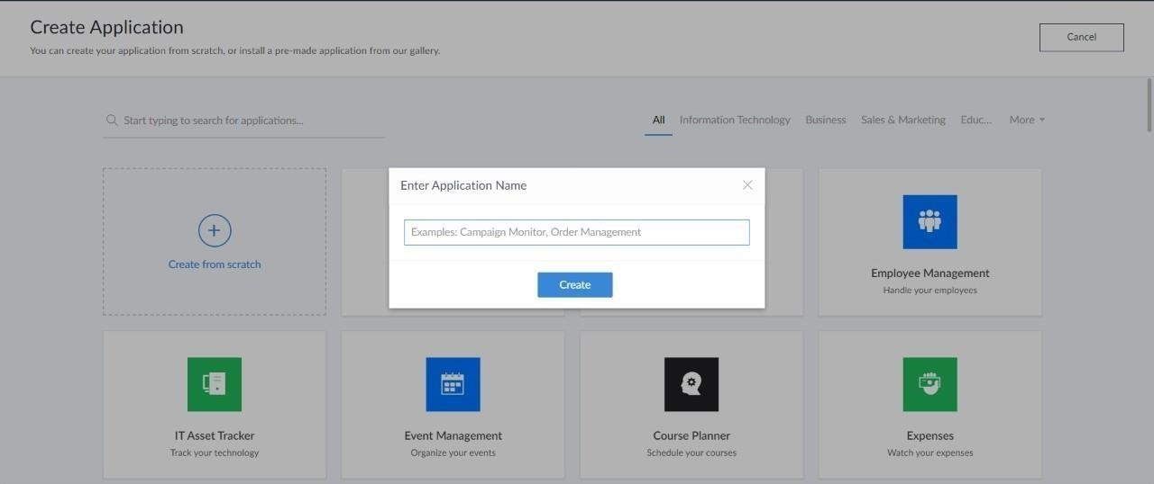

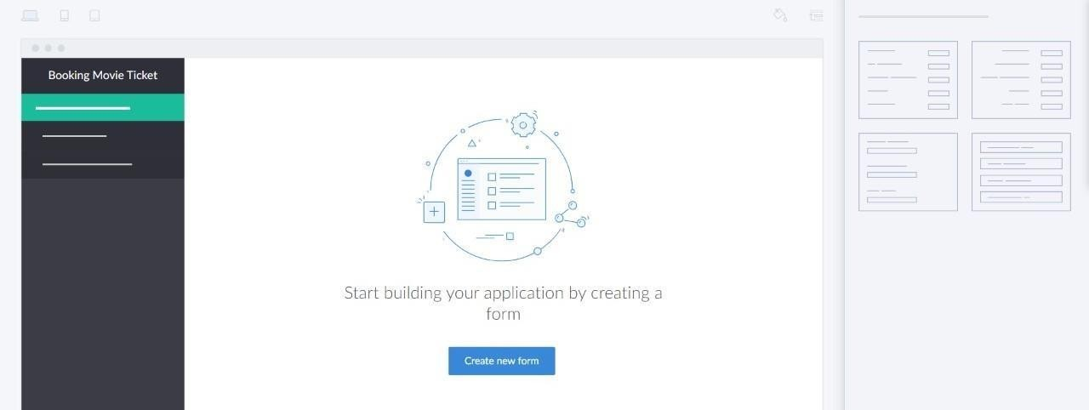

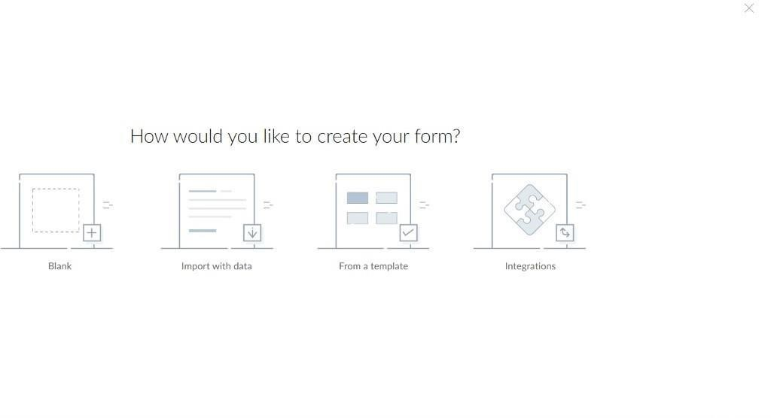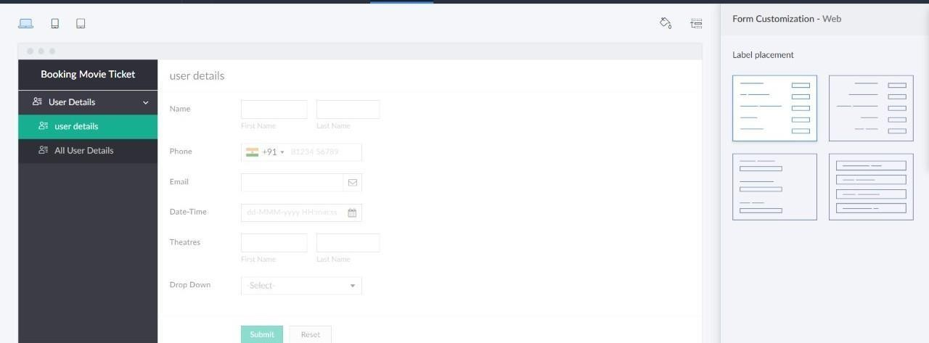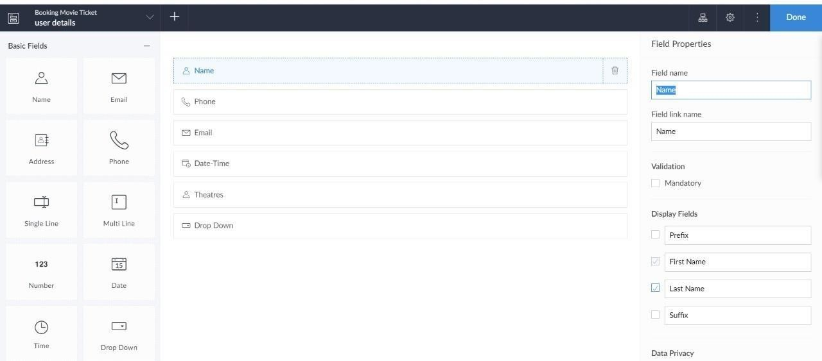

**EX. NO ; 2 CREATE A SIMPLE CLOUD SOFTWARE APPLICATION FOR FLIGHT RESERVATION SYSTEM USING ANY CLOUD SERVICE PROVIDER TO DEMONSTRATE SAAS**.

**DATE OF EXPERIMENT: 16-09-2024**

**AIM ;** To create a simple cloud software application for flight reservation system using any cloud service provider to demonstrate saas.

# SCREEN SHOTS AND OUTPUT:















## EXP NO 3: CREATE A SIMPLE CLOUD SOFTWARE APPLICATION FOR PROPERTY BUYING & RENTAL PROCESS (IN CHENNAI CITY) USING ANY CLOUD SERVICE PROVIDER TO DEMONSTRATE SAAS.

**DATE: 16-09-2024**

**AIM:**

To Create a simple cloud software application for Property Buying & Rental process (In Chennai city) using any Cloud Service Provider to demonstrate SaaS.

# SCREEN SHOTS AND OUTPUT:

















## EXP NO 4: CREATE A SIMPLE CLOUD SOFTWARE APPLICATION FOR CAR BOOKING RESERVATION SYSTEM USING ANY CLOUD SERVICE PROVIDER TO DEMONSTRATE SAAS.

**DATE: 16-09-2024**

**AIM:**

To Create a simple cloud software application for Car Booking Reservation System using any Cloud Service Provider to demonstrate SaaS.

# SCREEN SHOTS AND OUTPUT:















## EXP NO 5: CREATE A SIMPLE CLOUD SOFTWARE APPLICATION FOR LIBRARY BOOK RESERVATION SYSTEM FOR SIMATS LIBRARY USING ANY CLOUD SERVICE PROVIDER TO DEMONSTRATE SAAS

**DATE: 16-09-2024**

**AIM:**

To Create a simple cloud software application for Library book reservation system for SIMATS library using any Cloud Service Provider to demonstrate SaaS

# SCREEN SHOTS AND OUTPUT:













**.**





**EXP NO 6: CREATE A SIMPLE CLOUD SOFTWARE APPLICATION FOR PRODUCT SELLING USING ANY CLOUD SERVICE PROVIDER TO DEMONSTRATE SAAS.**

**DATE: 16-09-2024**

**AIM:**

To create a simple cloud software application for product selling using any cloud service provider to demonstrate saas.

# SCREEN SHOTS AND OUTPUT:















## EXP NO 7: DEMONSTRATE VIRTUALIZATION BY INSTALLING TYPE-2 HYPERVISOR IN YOUR DEVICE, CREATE AND CONFIGURE VM IMAGE WITH A HOST OPERATING SYSTEM (EITHER WINDOWS/LINUX).

**DATE: 17-09-2024**

**AIM:**

To demonstrate virtualization by installing type-2 hypervisor in your device, create and configure VM image with a host operating system (either windows/linux).

# SCREEN SHOTS AND OUTPUT:

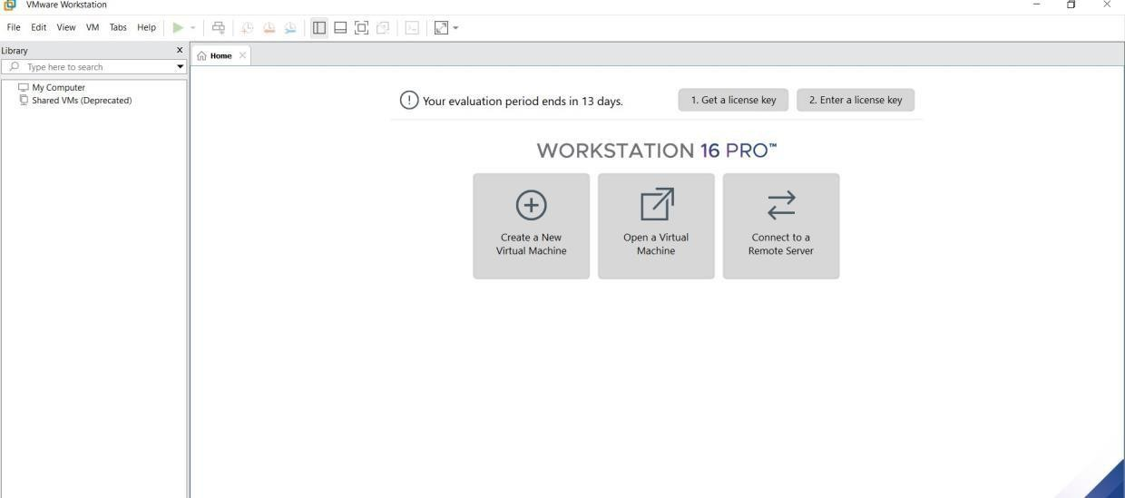

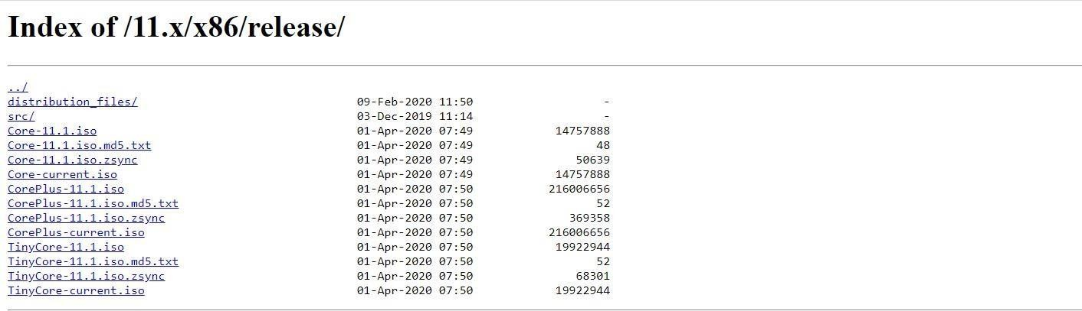

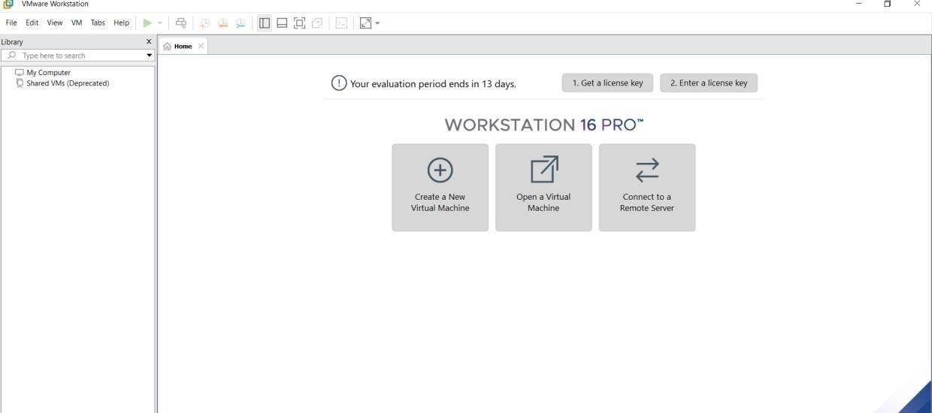

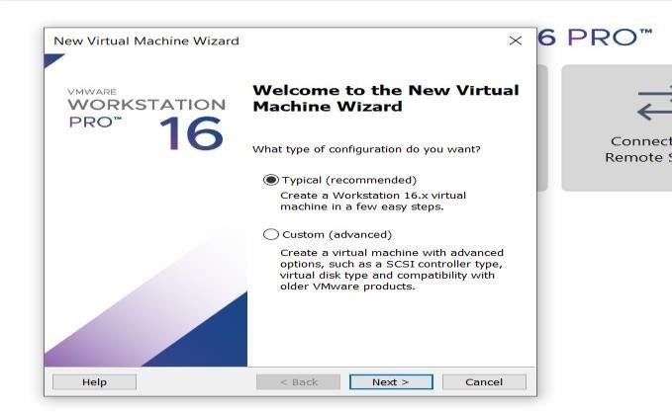

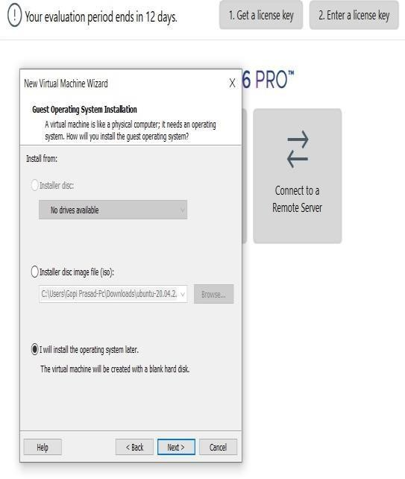

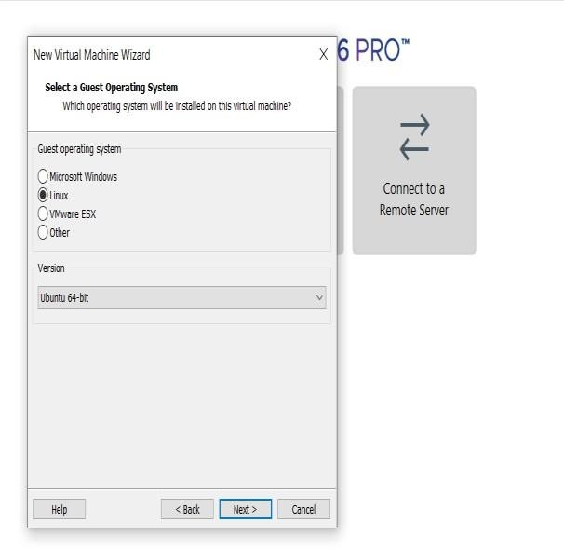

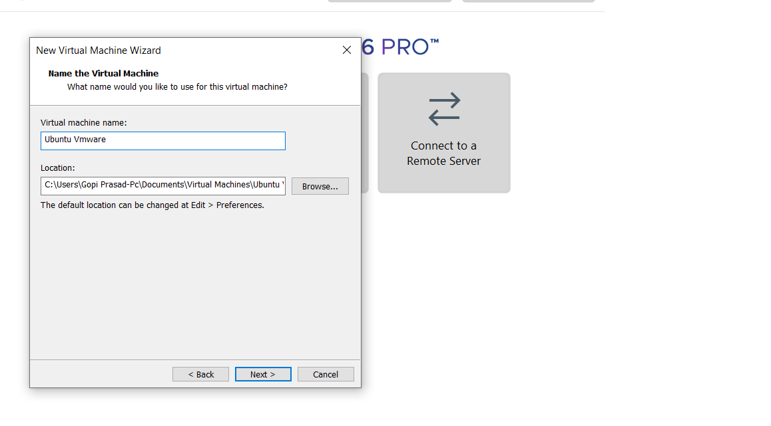

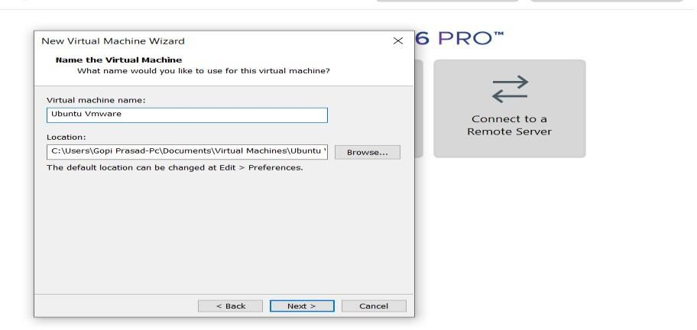

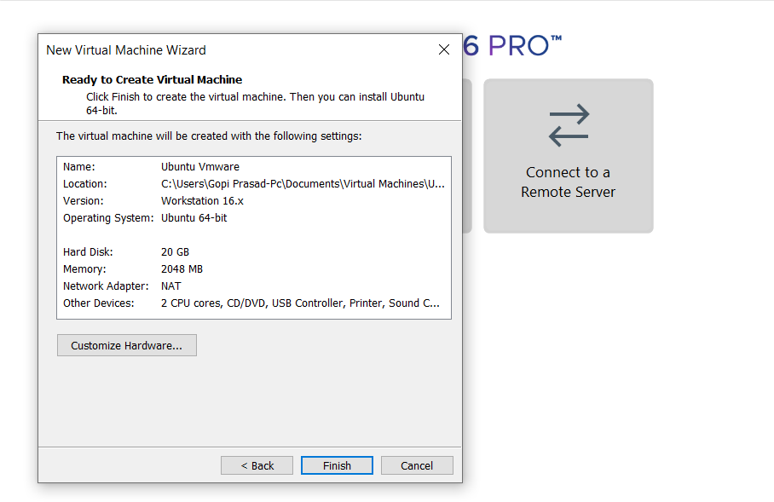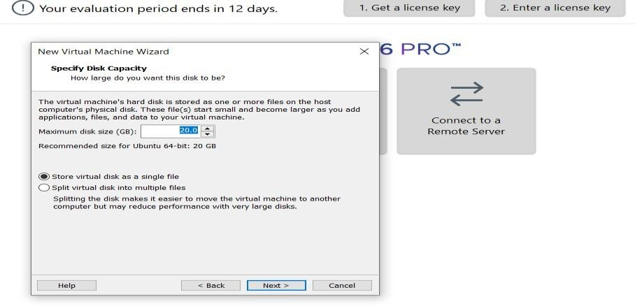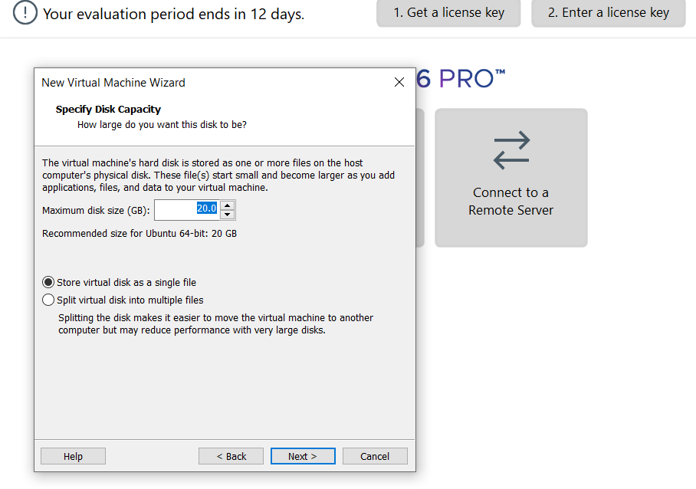

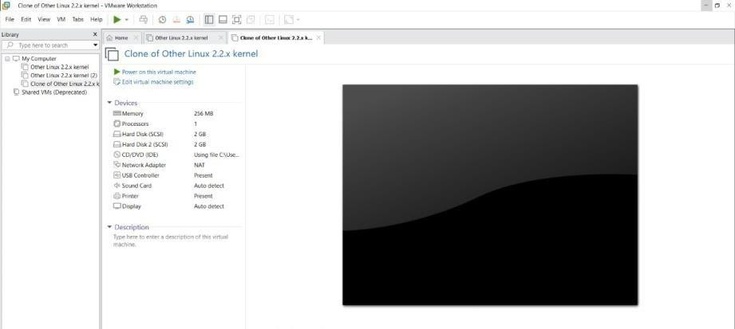

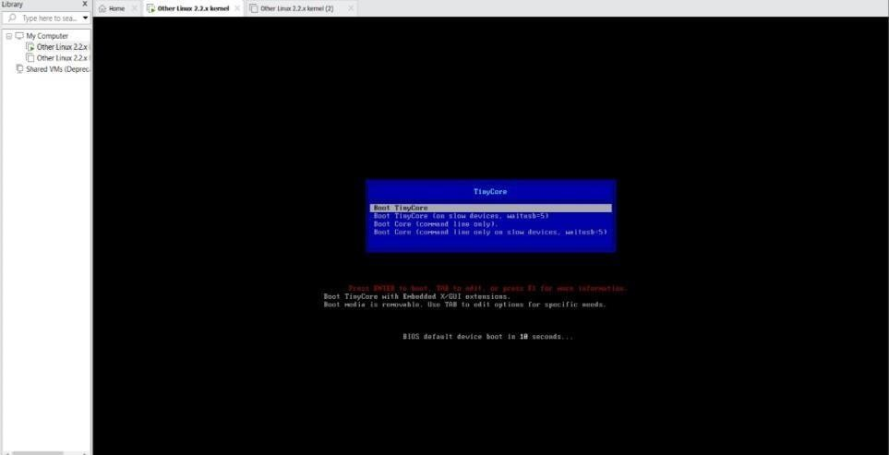

**EXPNO 8: CREATE A VIRTUAL MACHINE WITH 1 CPU, 2GB RAM AND 15GBSTORAGE DISK USING A TYPE 2 VIRTUALIZATION SOFTWARE.**

**DATE: 17-09-2024**

**AIM:**

To create a virtual machine with 1 cpu, 2gb ram and 15gbstorage disk using a type 2 virtualization software**.**

# SCREEN SHOTS AND OUTPUT:





















**EXP 9: CREATE A VIRTUAL HARD DISK AND ALLOCATE THE STORAGEUSING VM WARE WORKSTATION.**

**DATE: 17-09-2024**

**AIM:**

To create a virtual hard disk and allocate the storage using vm ware workstation

**Screenshots and output:**

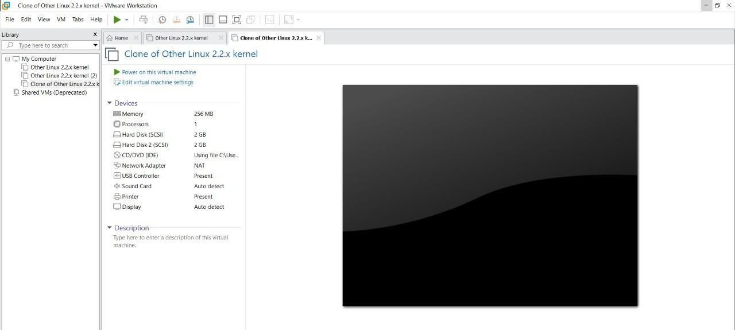

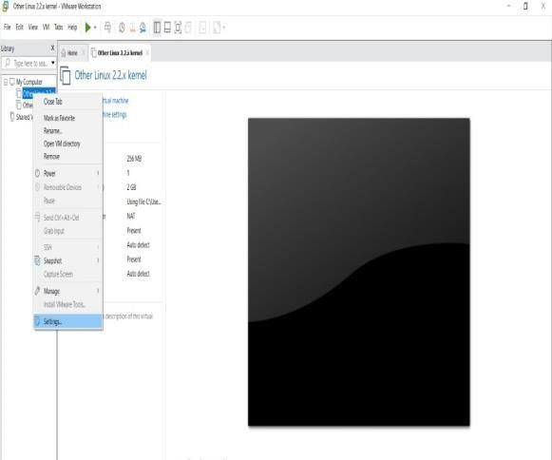

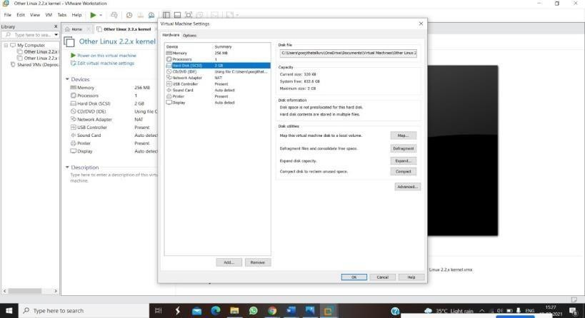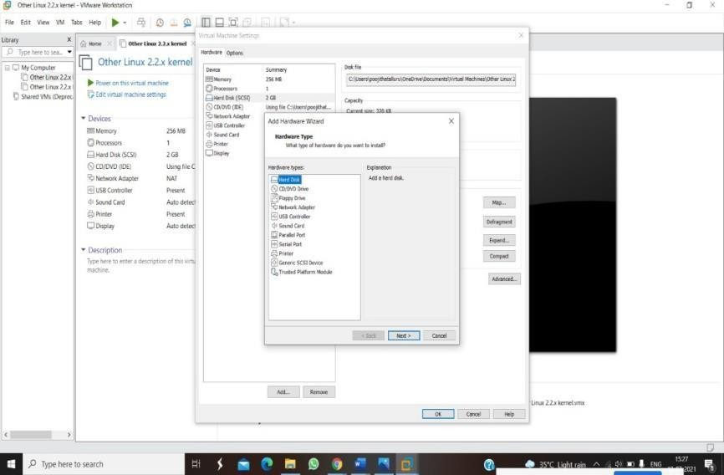

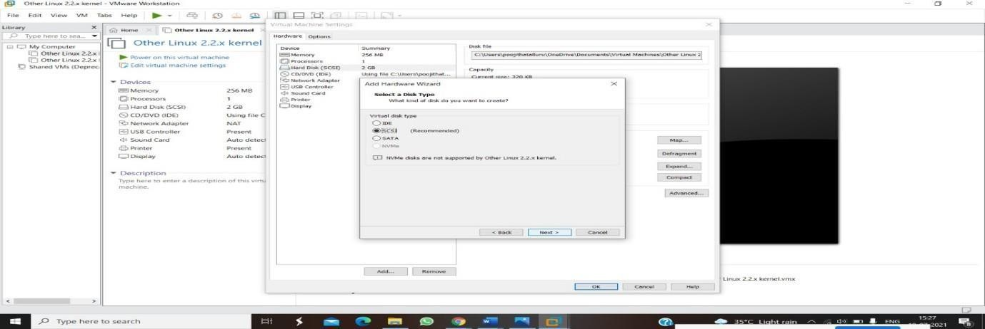

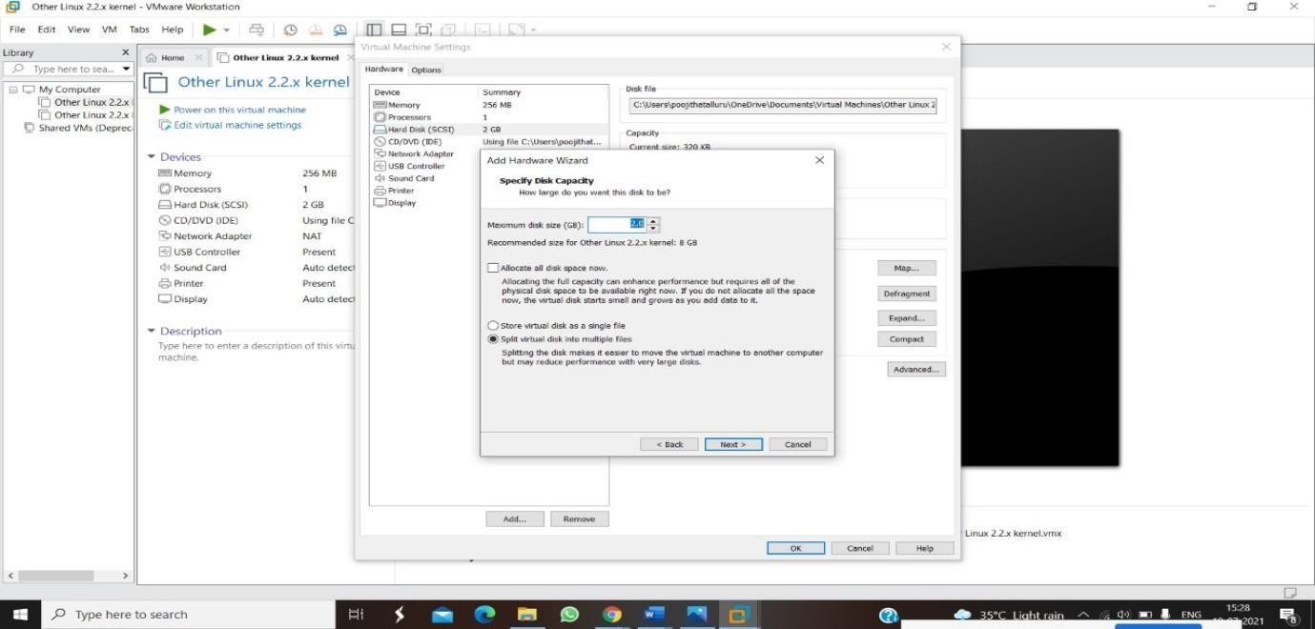

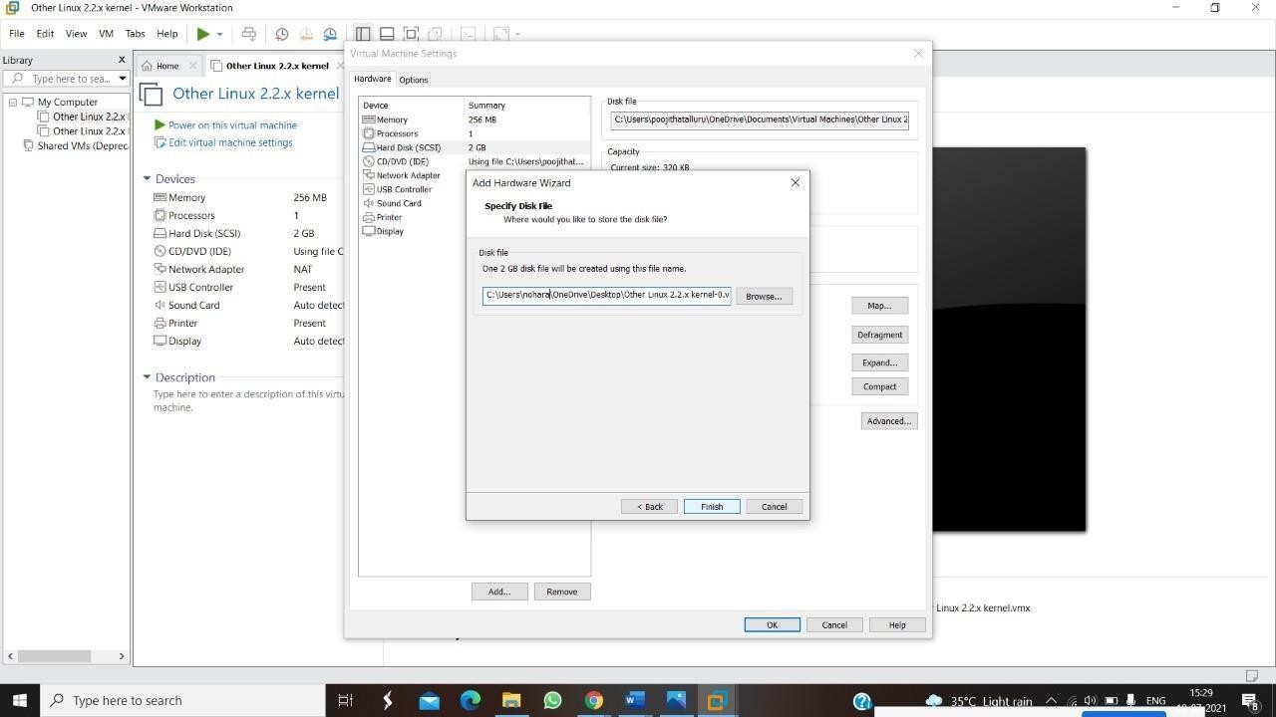

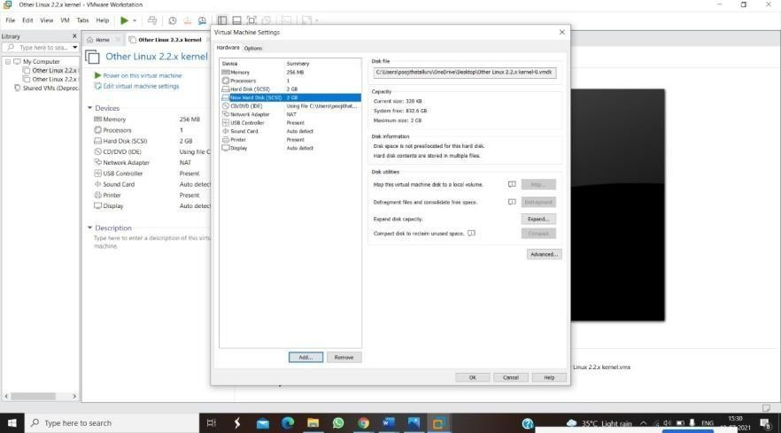

**EXPNO 10: CREATE A SNAPSHOT OF A VM AND TEST IT BY LOADING THE PREVIOUS VERSION/CLONED VM**

**DATE: 17-09-2024**

**AIM:**

To create a snapshot of a vm and test it by loading the previous version/cloned vm

**Screenshots and outputs:**

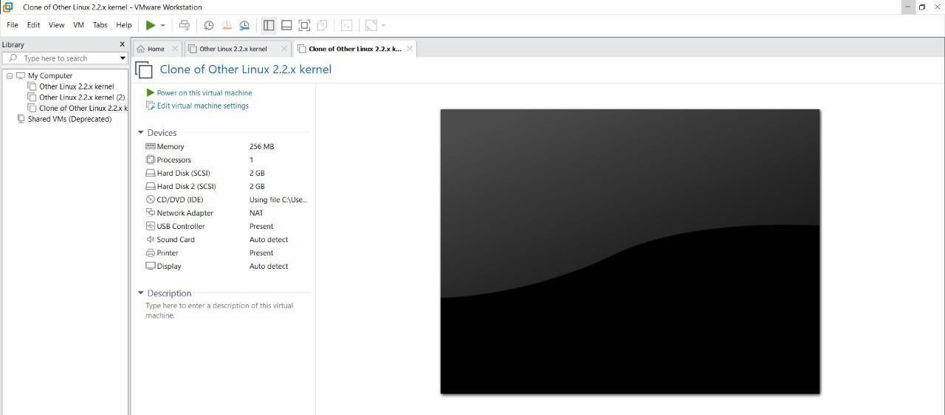

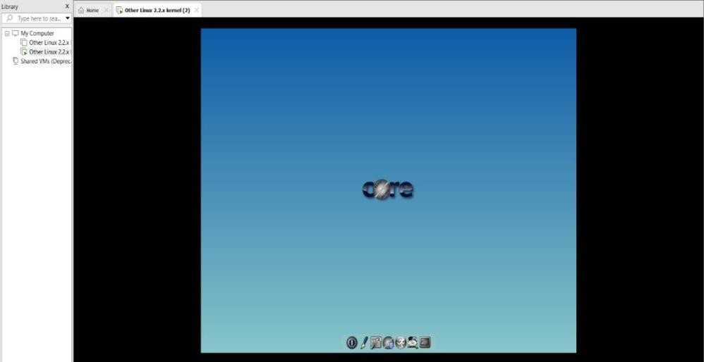

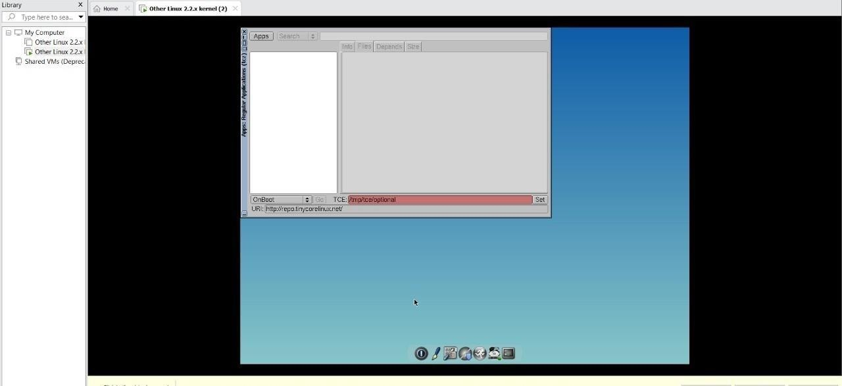

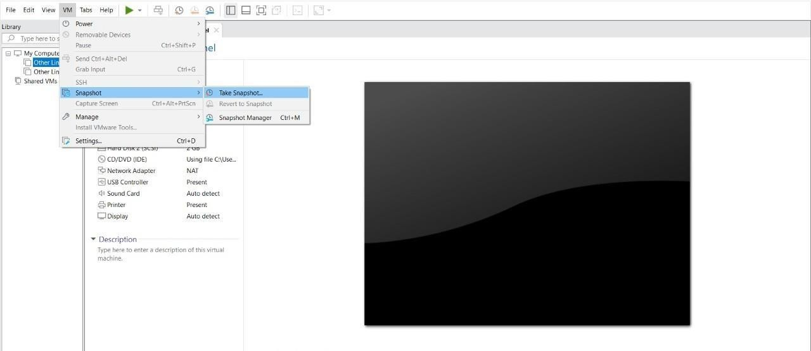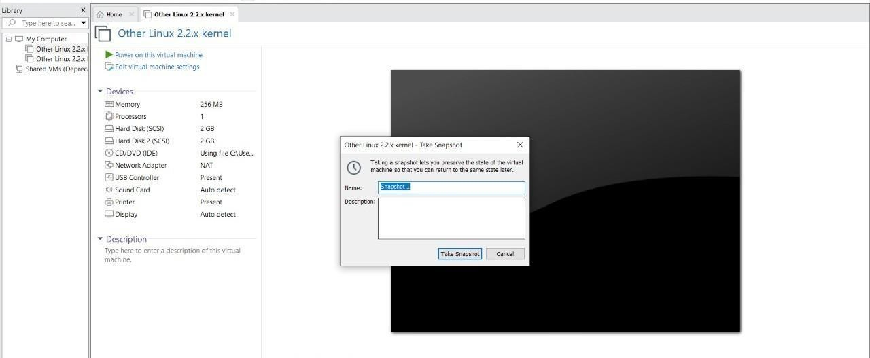

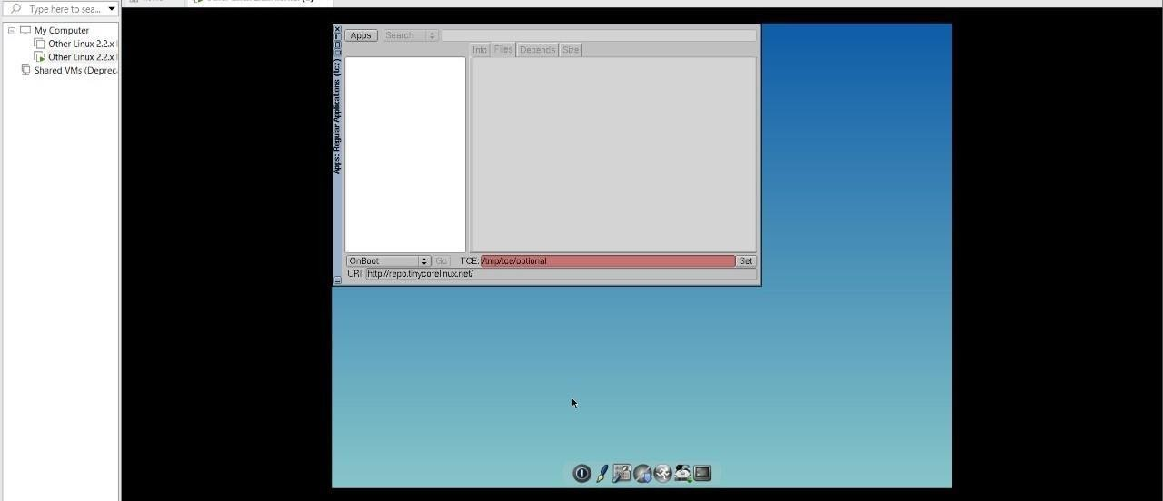

**EXPNO 11: CREATE A CLONING OF A VM AND TEST IT BY LOADING THE PREVIOUS VERSION/CLONED VM.**

**DATE: 17-09-2024**

**AIM:**

To create a cloning of a vm and test it by loading the previous version/cloned vm.

**Screenshots and outputs:**

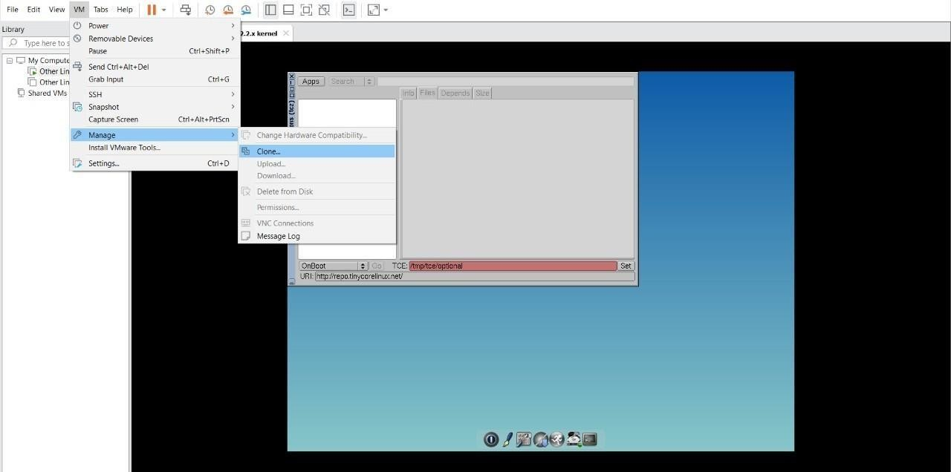

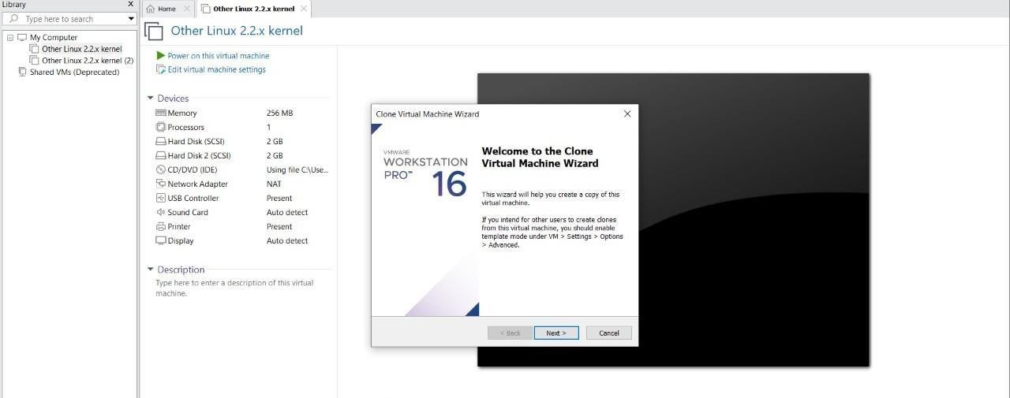

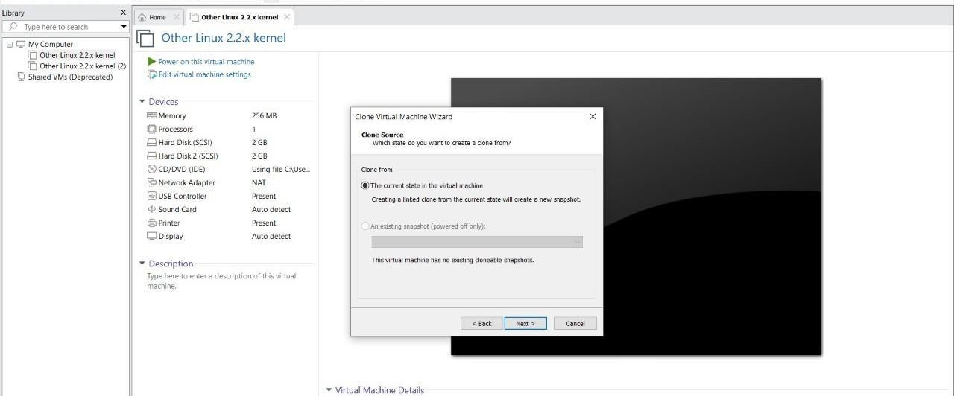

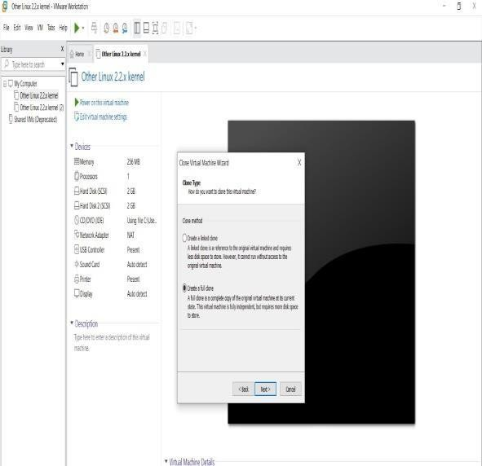

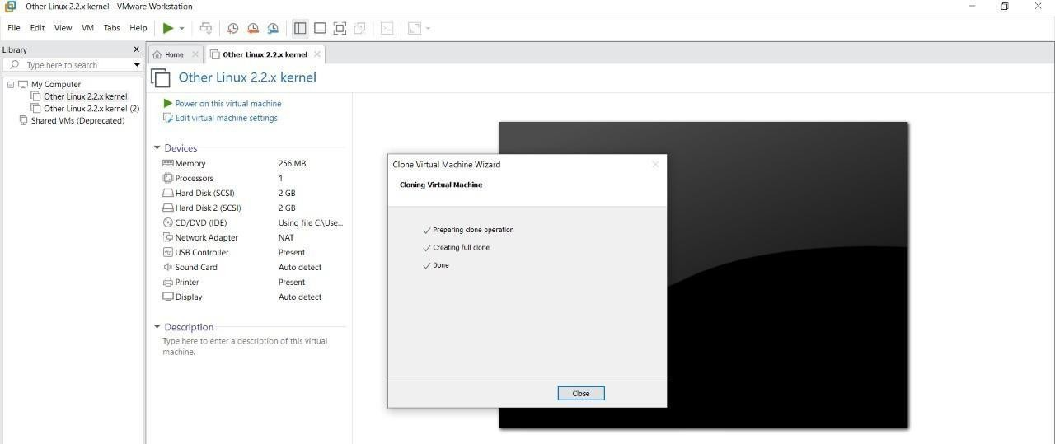

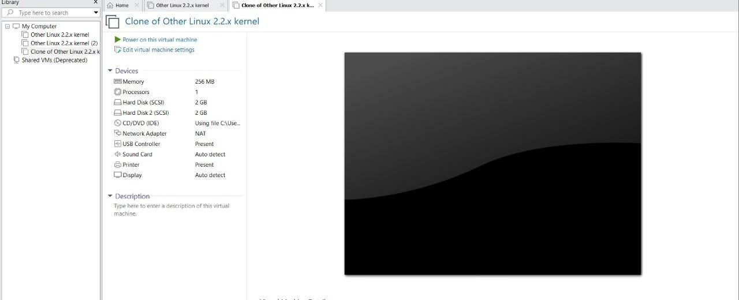

## EXP 12: CHANGE HARDWARE COMPATIBILITY OF A VM (EITHER BY CLONE/CREATE NEW ONE) WHICH IS ALREADY CREATED AND CONFIGURED.

**DATE: 17-09-2024**

**AIM:**

To Change Hardware compatibility of a VM (Either by clone/create new one) which is already created and configured.

**Screenshots and Outputs:**















## EXP13. DEMONSTRATE INFRASTRUCTURE AS A SERVICE (IAAS) BY CREATING A VIRTUAL MACHINE USING A PUBLIC CLOUD SERVICE PROVIDER (AZURE), CONFIGURE WITH REQUIRED MEMORY AND CPU.

**Date:18-09-2024**

## AIM:

To demonstrate infrastructure as a service (iaas) by creating a virtual machine using a public cloud service provider (azure), configure with required memory and cpu.

**Screenshots and Outputs:**

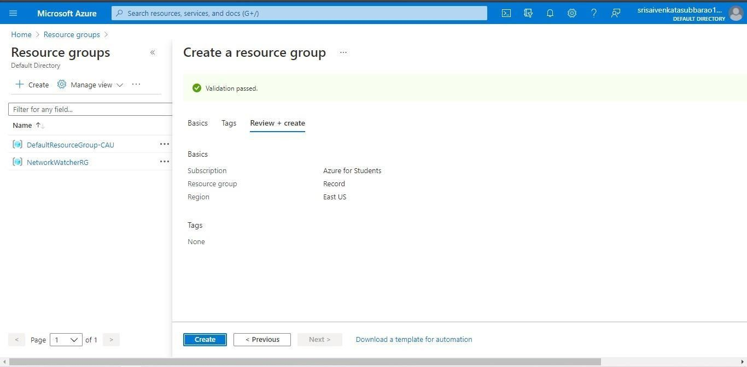

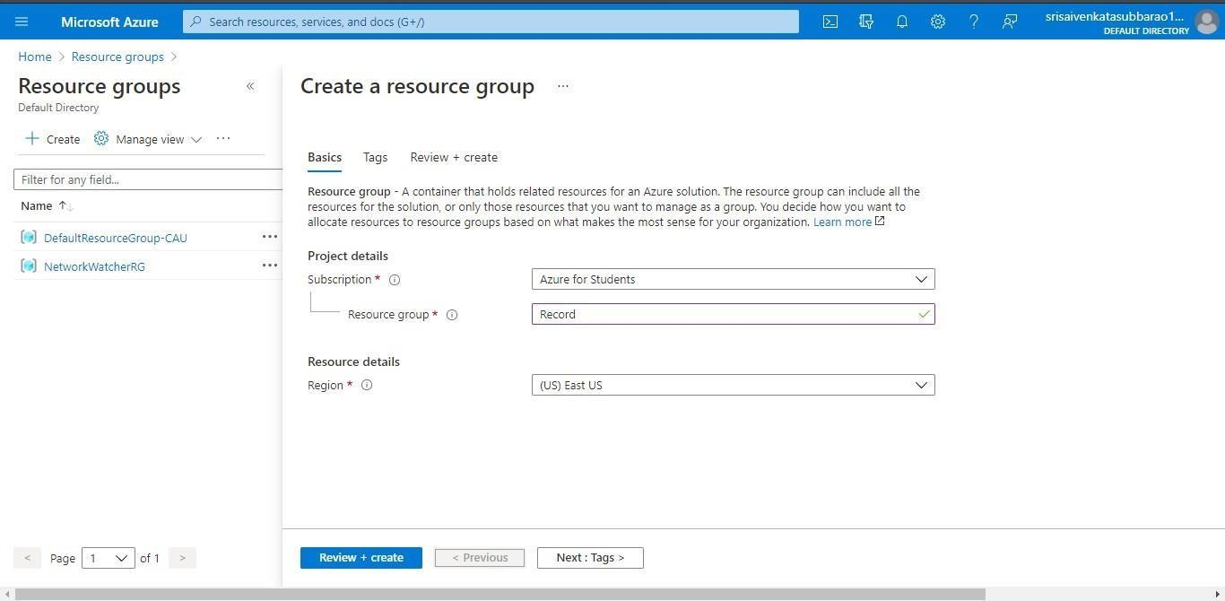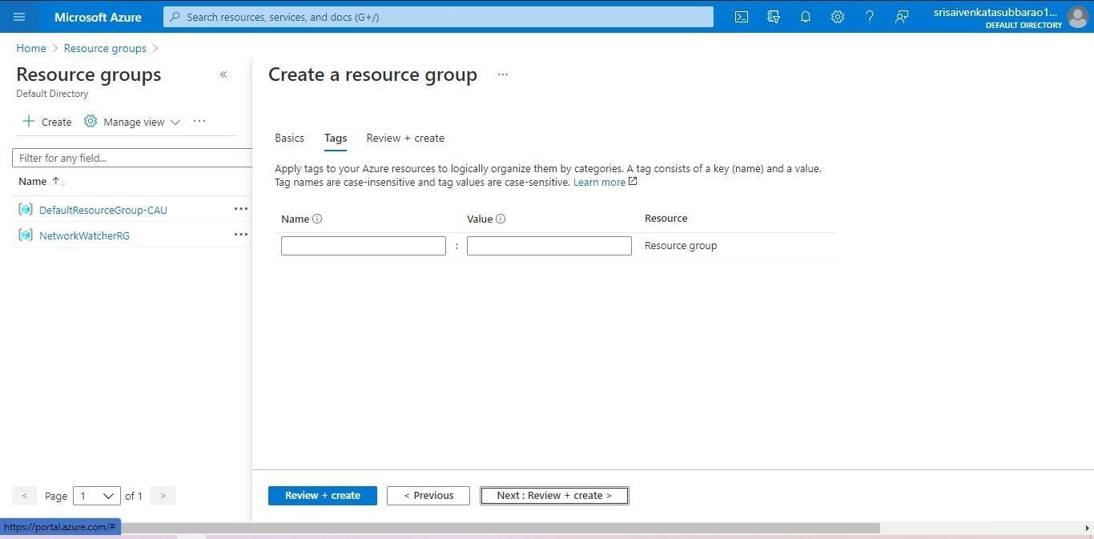

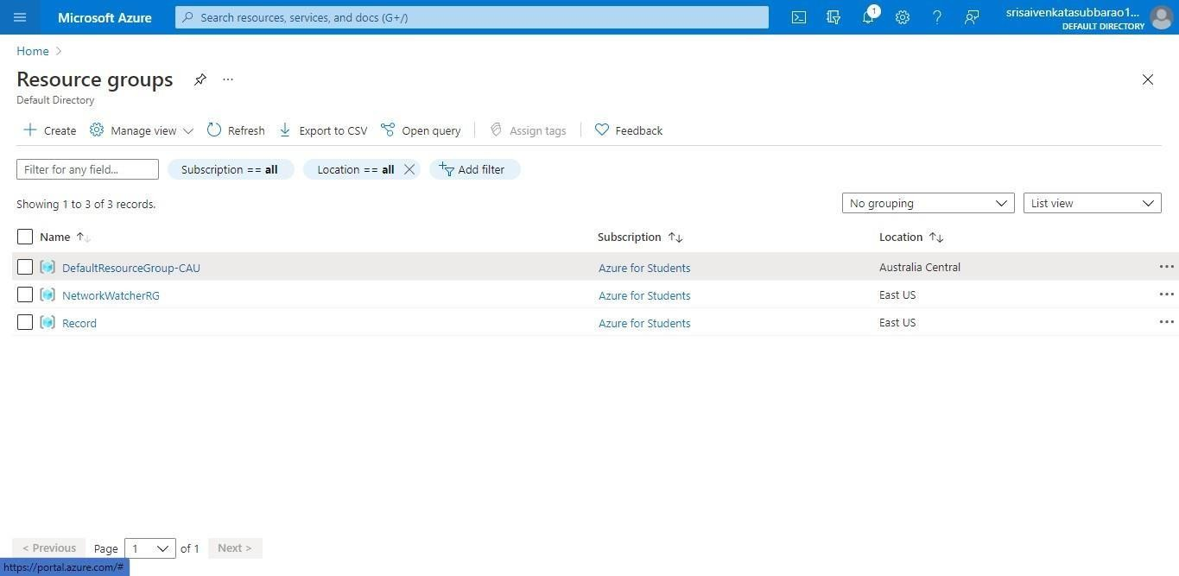

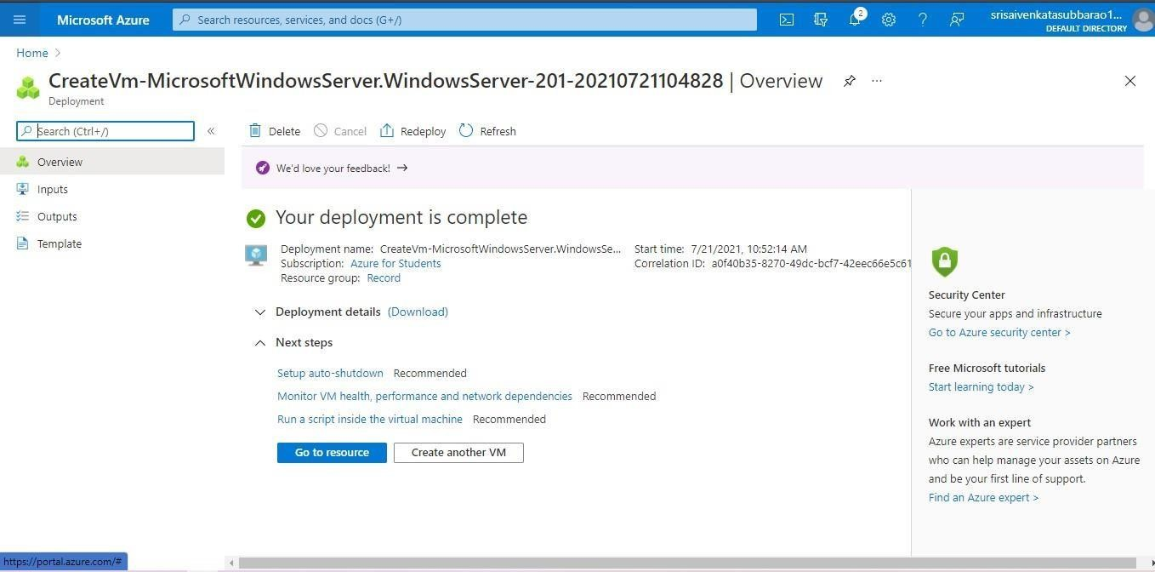

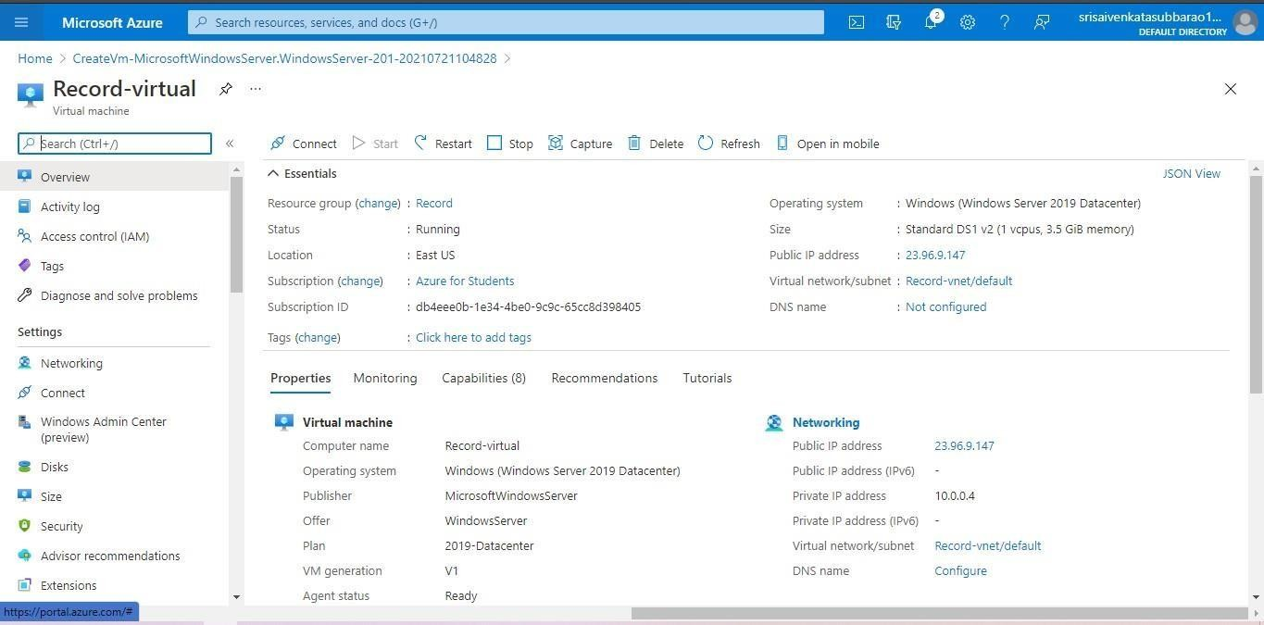



**EXP 17 .DEMONSTRATE INFRASTRUCTURE AS A SERVICE(IAAS) BY CREATING AVIRTUAL MACHINE USING A PUBLIC CLOUD SERVICE PROVIDER(AZURE/GCP/AWS) CONFIGURE WITH MINIMUM CPU, RAM ANDSTORAGE AND LAUNCH THE VM IMAGE.**

**Date:18-09-2024**

## AIM:

To demonstrate infrastructure as a service(iaas) by creating a virtual machine using a public cloud service provider(azure/gcp/aws) configure with minimum cpu,ram and storage and launch the vm image.

**Screenshots and outputs:**













**EXP15.CREATE A SIMPLE WEB SITE USING ANY PUBLIC CLOUD SERVICE PROVIDER (AZURE/GCP/AWS) AND CHECK THE PUBLIC ACCESSIBILITY OFTHE STORED FILE TO DEMONSTRATE STORAGE AS A SERVICE**

**Date:19-09-2024**

**AIM:** CREATE A SIMPLE WEB SITE USING ANY PUBLIC CLOUD SERVICE PROVIDER (AZURE/GCP/AWS) AND CHECK THE PUBLIC ACCESSIBILITY OFTHE STORED FILE TO DEMONSTRATE STORAGE AS A SERVICE

**Screenshots and Outputs:**

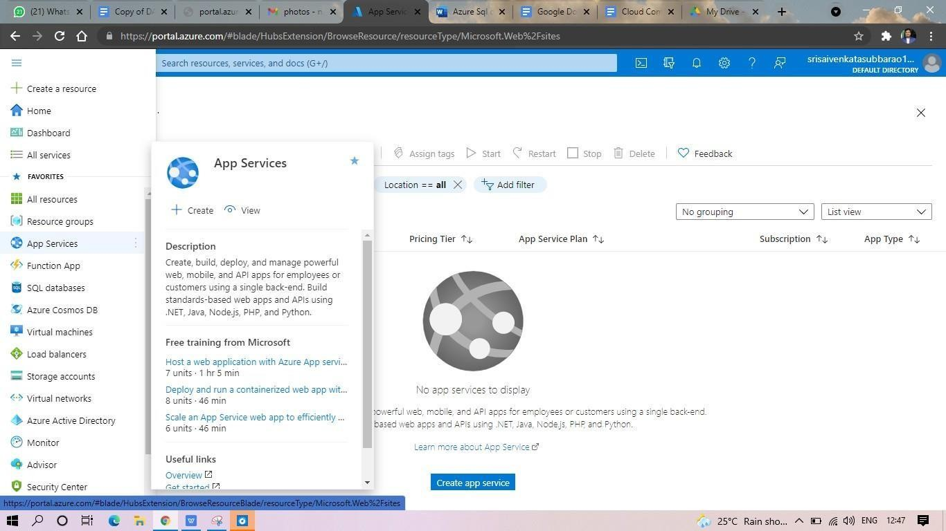

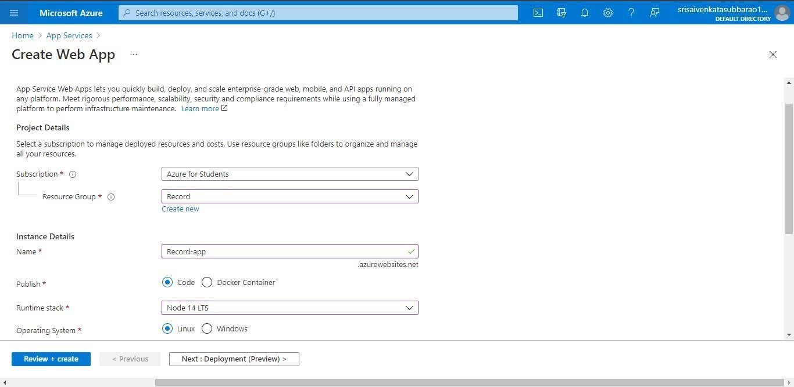

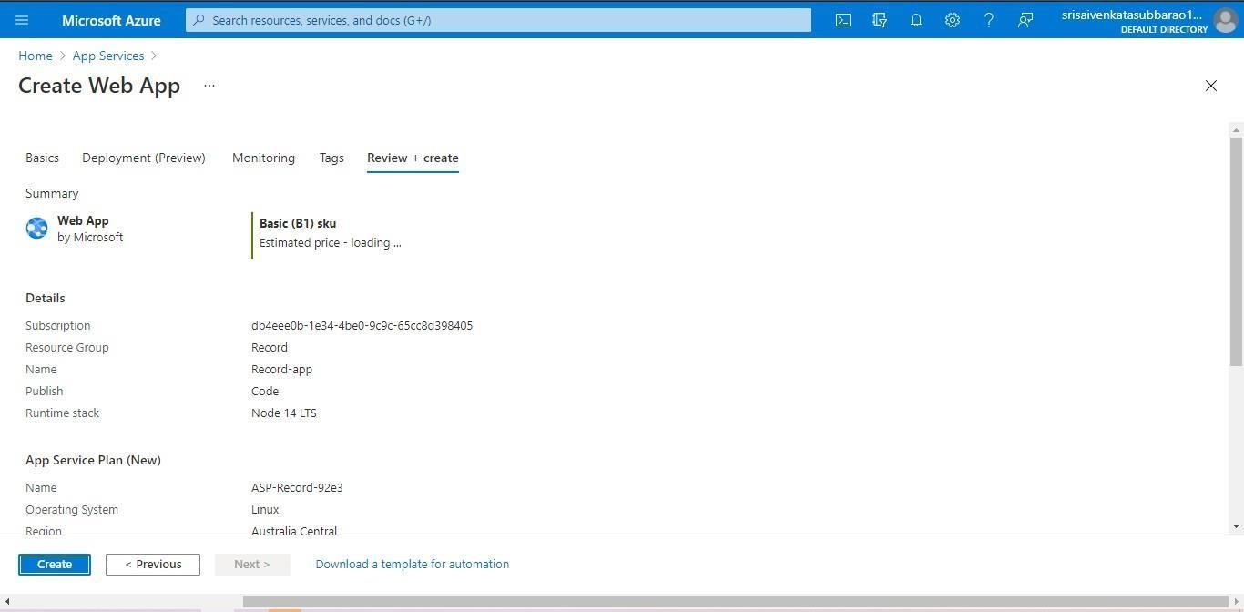

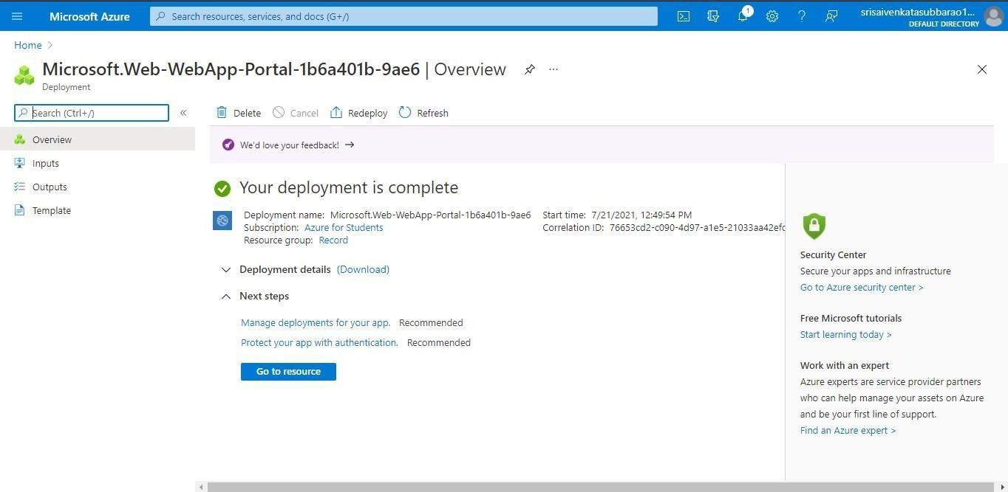

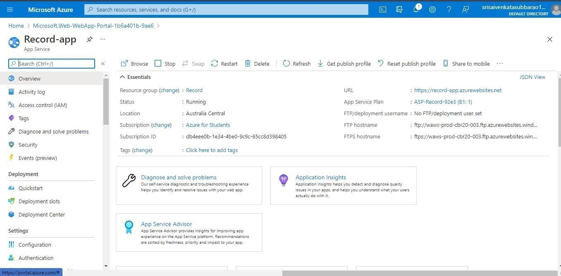

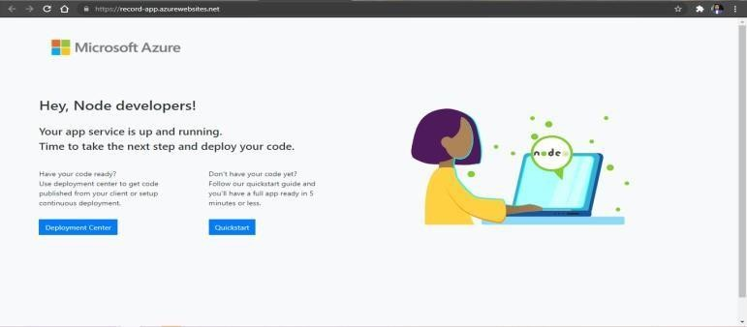

**EXP 17 .DEMONSTRATE INFRASTRUCTURE AS A SERVICE(IAAS) BY CREATING AVIRTUAL MACHINE USING A PUBLIC CLOUD SERVICE PROVIDER(AZURE/GCP/AWS) CONFIGURE WITH MINIMUM CPU, RAM ANDSTORAGE AND LAUNCH THE VM IMAGE.**

**Date:19-09-2024**

## AIM:

To demonstrate infrastructure as a service(iaas) by creating a virtual machine using a public cloud service provider(azure/gcp/aws) configure with minimum cpu,ram and storage and launch the vm image.

**Screenshots and Outputs:**













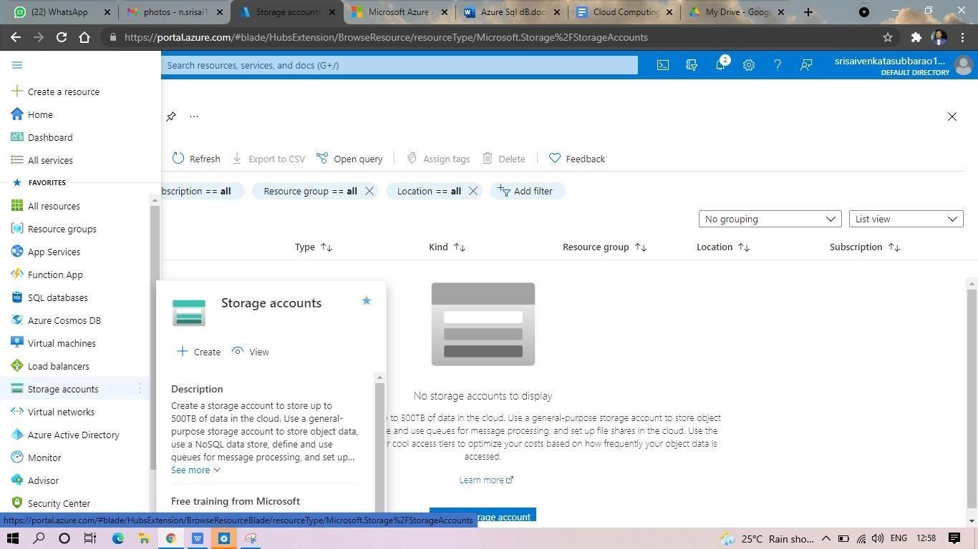

**EXP19.CREATE A STORAGE SERVICE USING ANY PUBLIC CLOUD SERVICE PROVIDER (AZURE/GCP/AWS) AND CHECK THE PUBLIC ACCESSIBILITY OFTHE STORED FILE TO DEMONSTRATE STORAGE AS A SERVICE. DATE: 20-09-2024**

**AIM: to create a storage service using any public cloud service provider (azure/gcp/aws) and check the public accessibility ofthe stored file to demonstrate storage as a service.**

**Screenshots and outputs:**

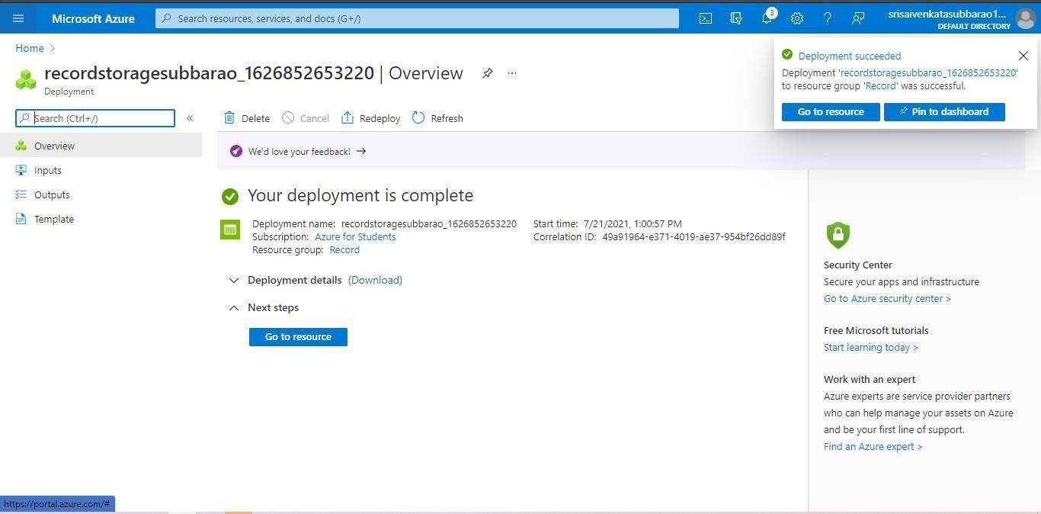

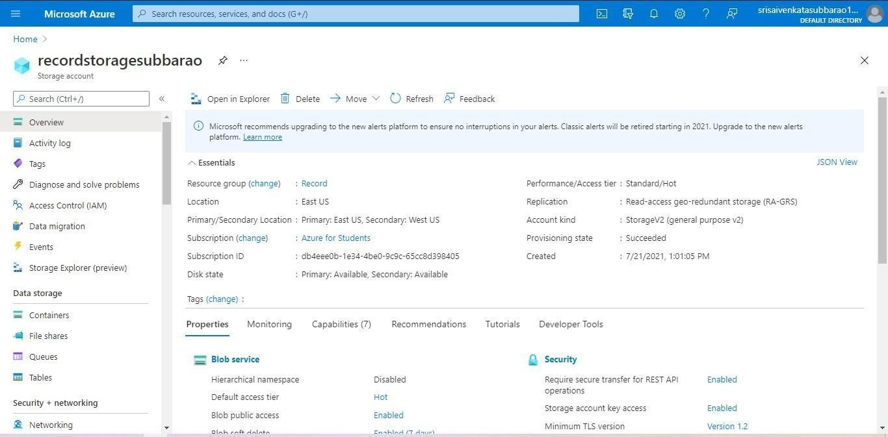

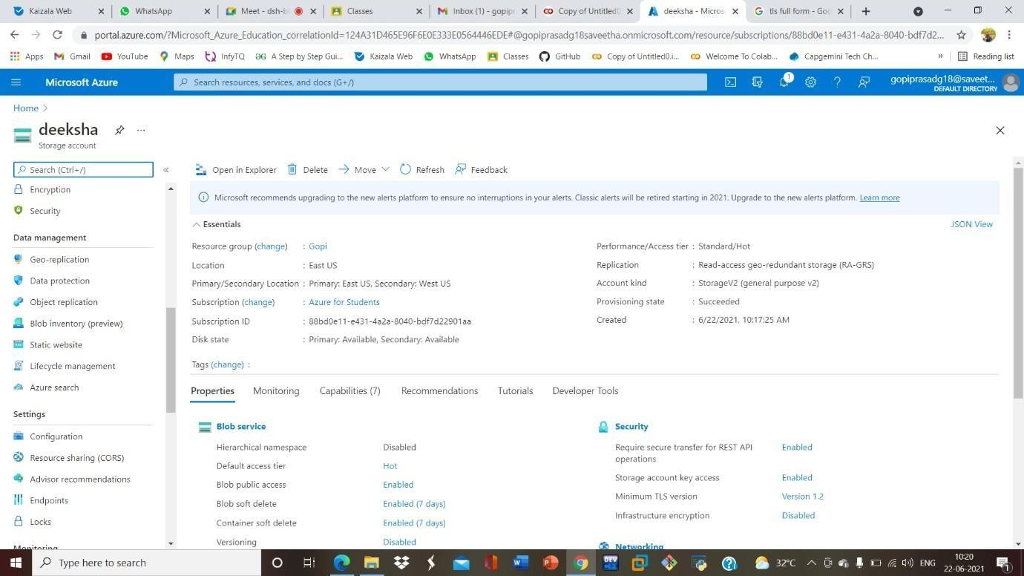

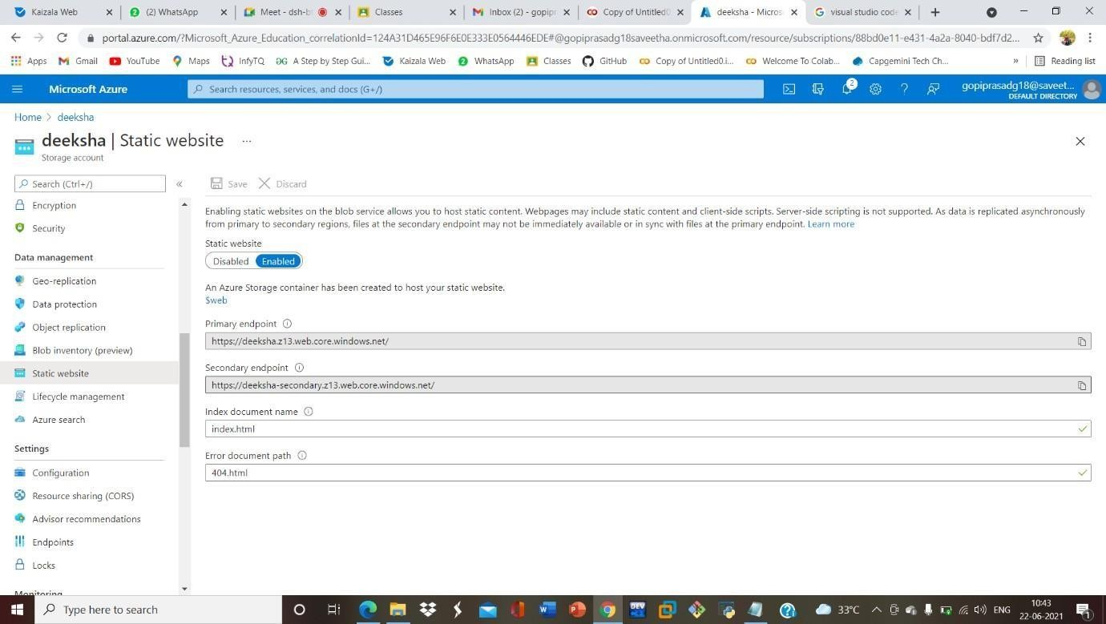

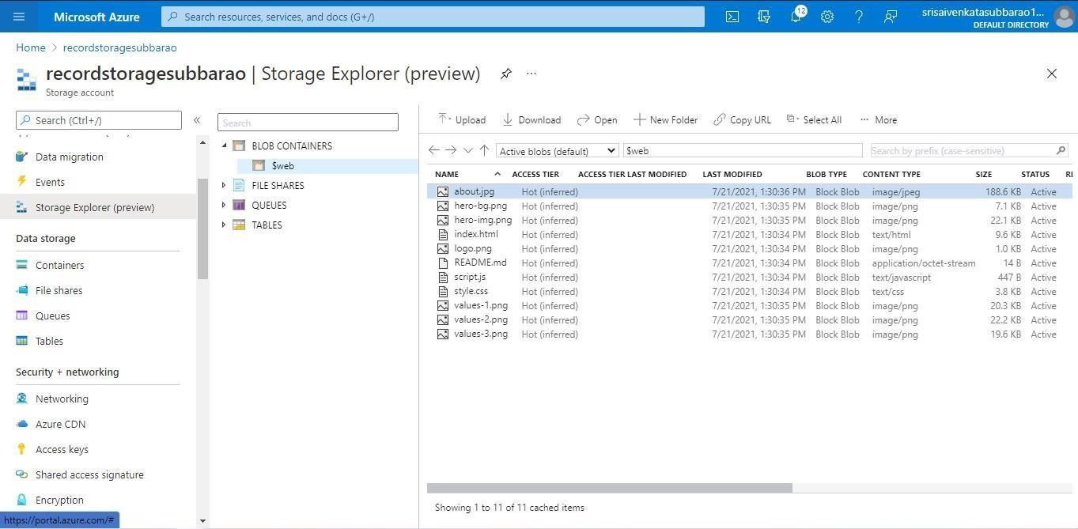

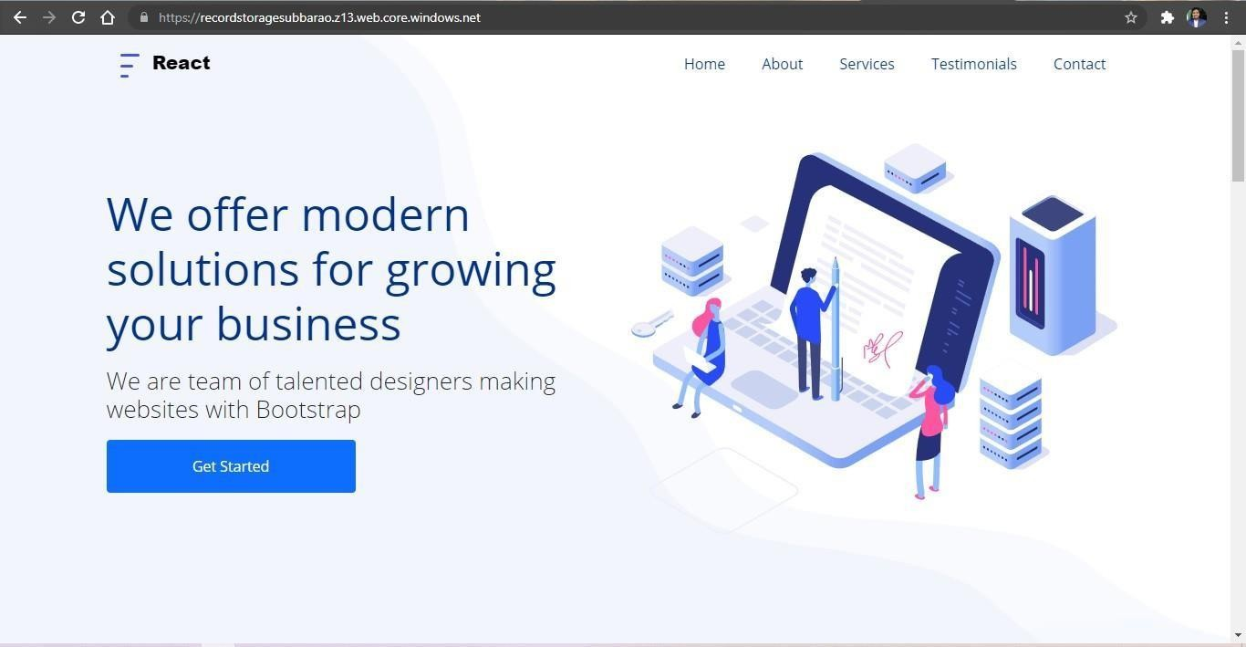

**EXP20.CREATE A SQL STORAGE SERVICE AND PERFORM A BASIC QUERY USINGANY PUBLIC CLOUD SERVICE PROVIDER (AZURE/GCP/AWS) TO DEMONSTRATE DATABASE AS A SERVICE (DAAS)**

**Date:20-09-2024**

**AIM:** CREATE A SQL STORAGE SERVICE AND PERFORM A BASIC QUERY USINGANY PUBLIC CLOUD SERVICE PROVIDER (AZURE/GCP/AWS) TO DEMONSTRATE DATABASE AS A SERVICE (DAAS)

**Screenshots and outputs:**

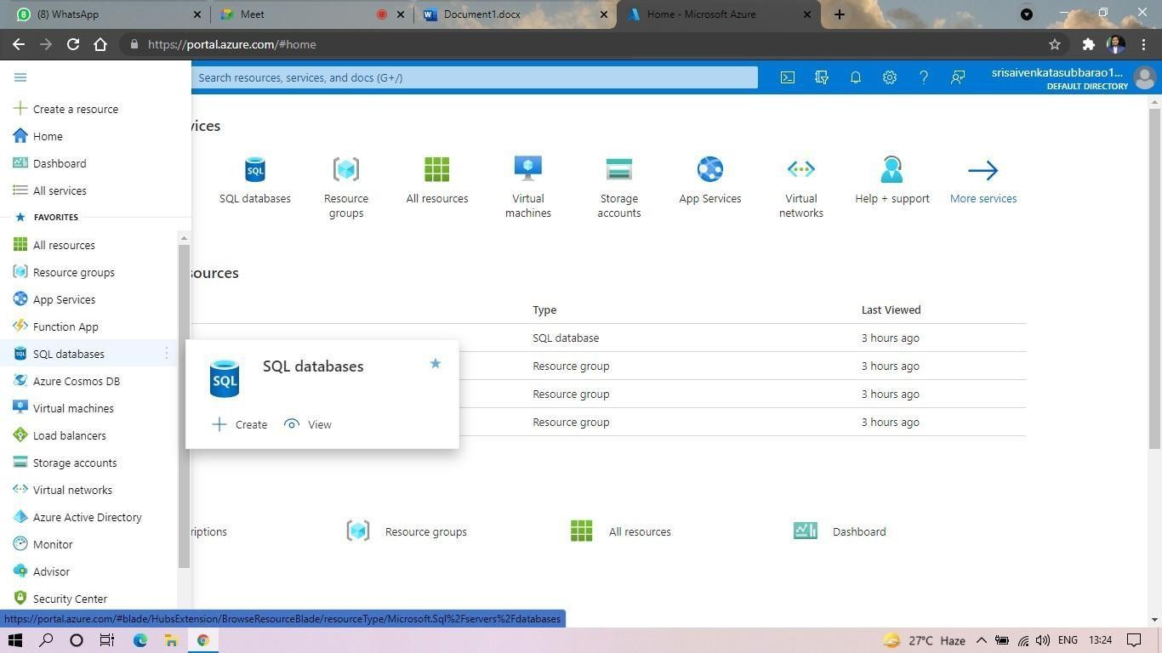

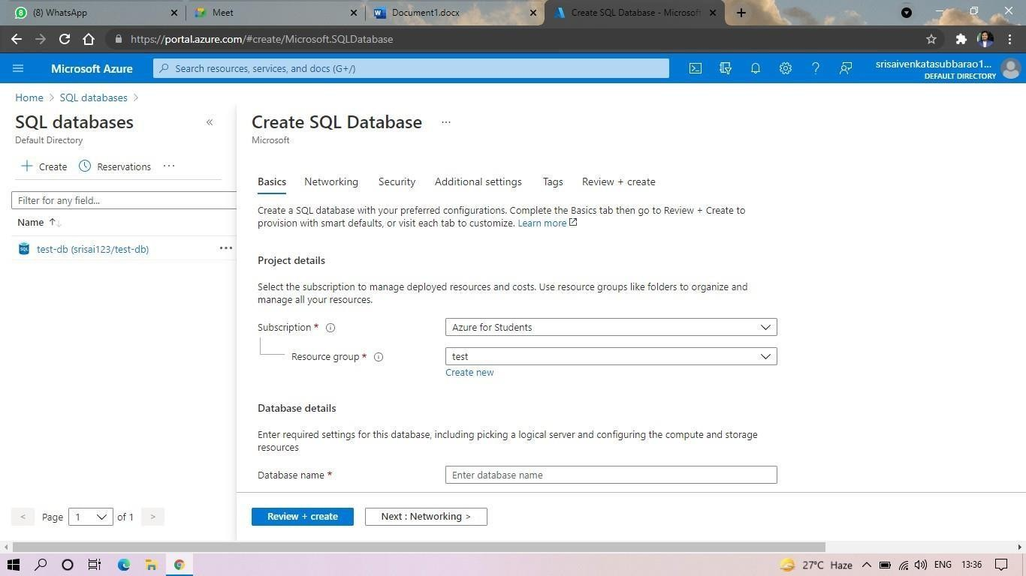

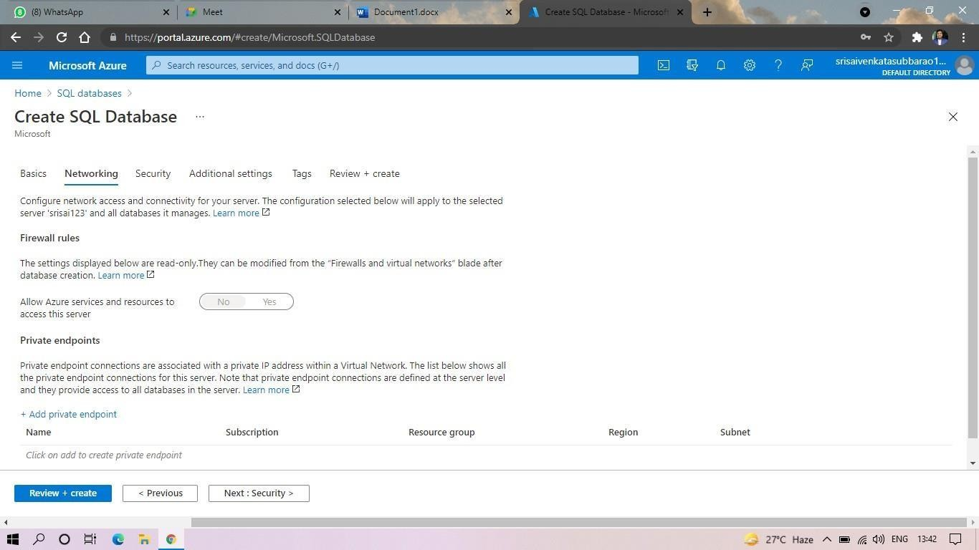

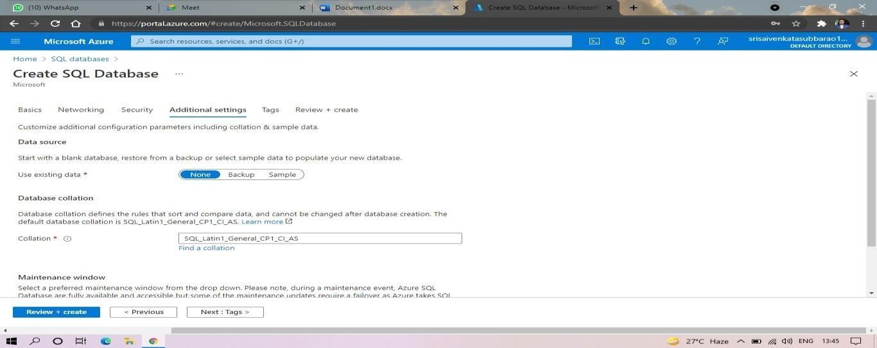

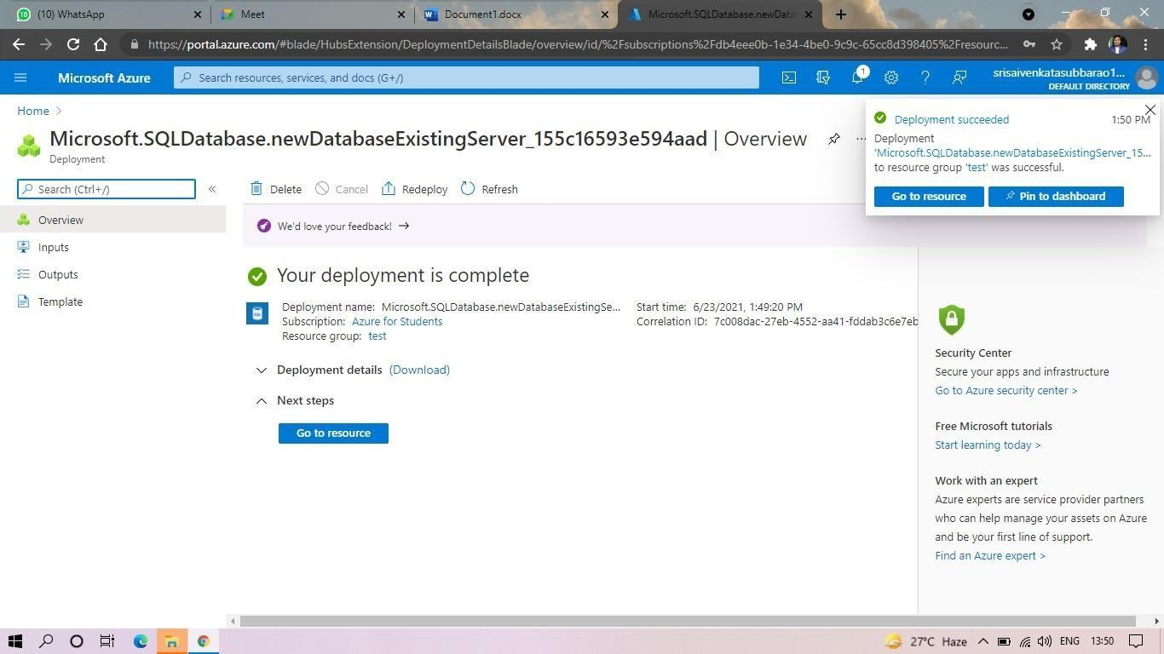

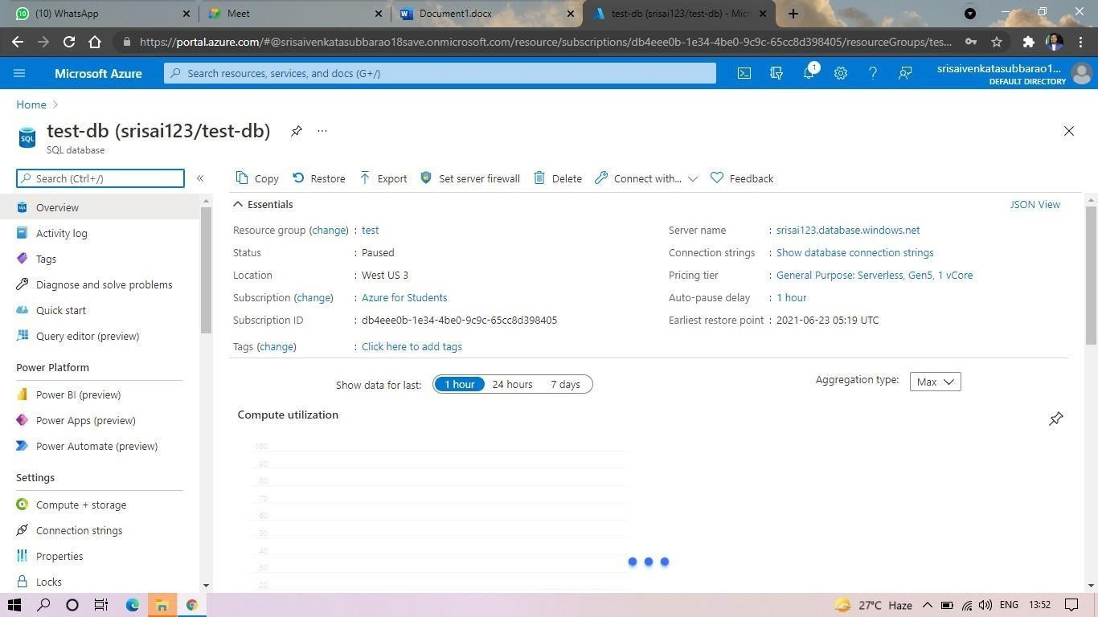

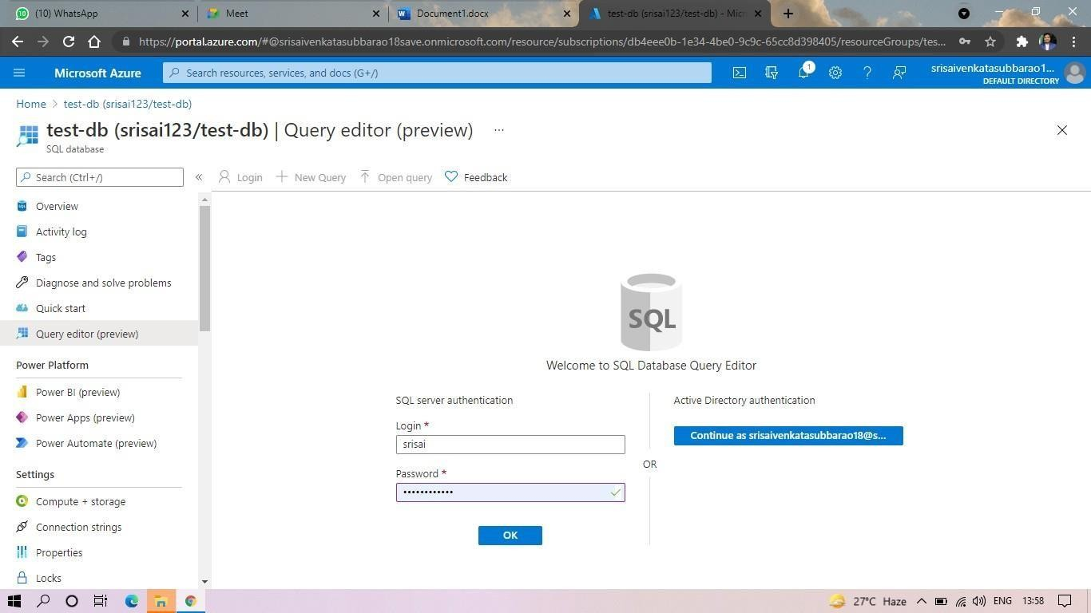

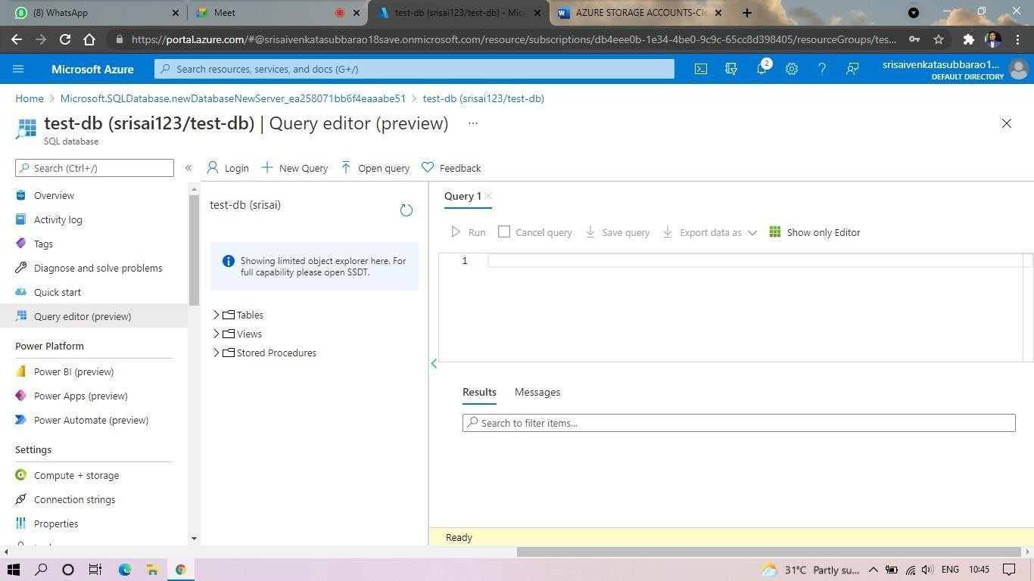

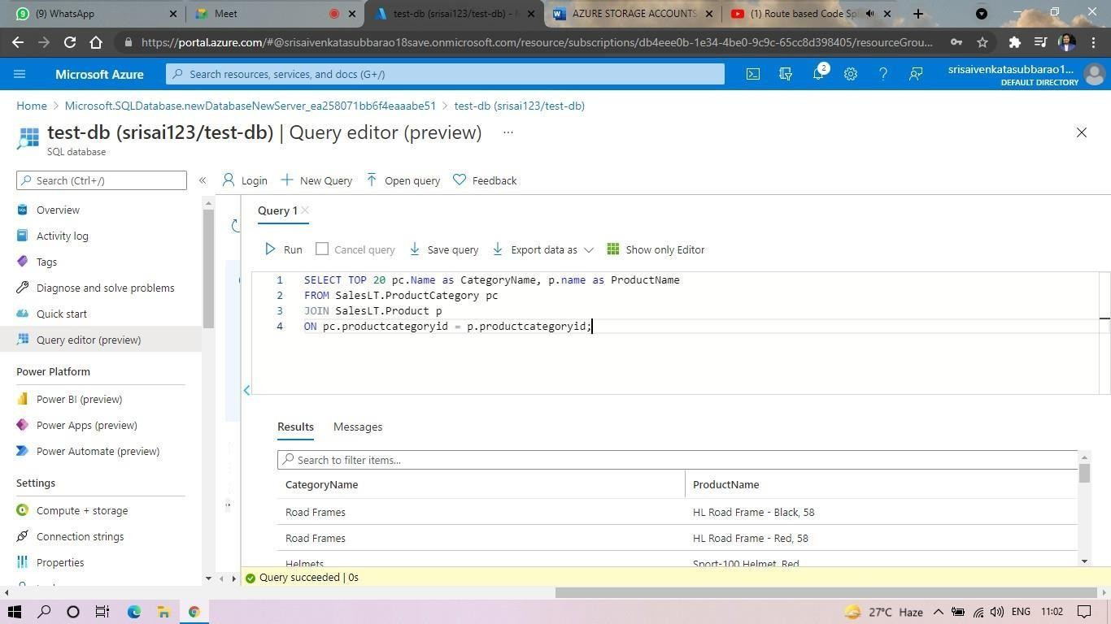

**EXP. 22: PERFORM THE BASIC CONFIGURATION SETUP FOR INSTALLINGHADOOP 2.X LIKE CREATING THE HDUSER AND SSH LOCALHOST**

**Date:21-09-2024**

**AIM:** PERFORM THE BASIC CONFIGURATION SETUP FOR INSTALLINGHADOOP 2.X LIKE CREATING THE HDUSER AND SSH LOCALHOST

**Screenshots and Outputs:**

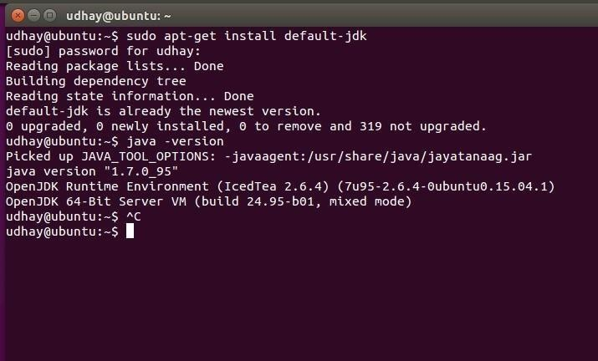

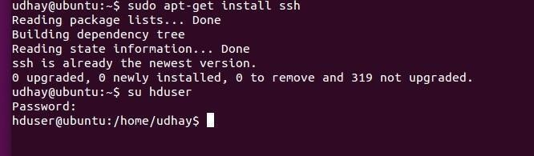

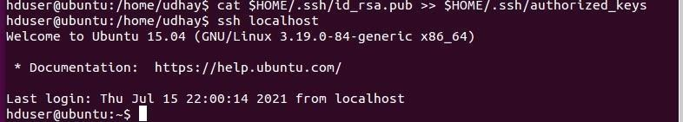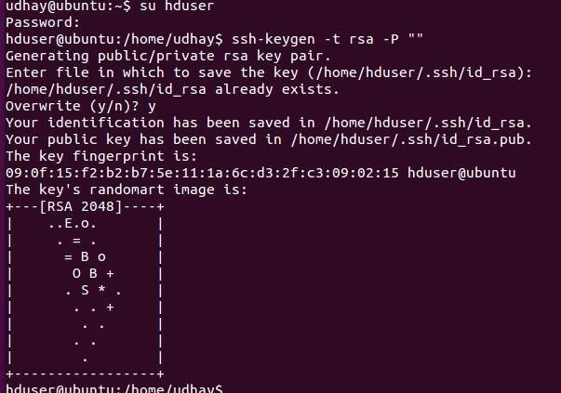

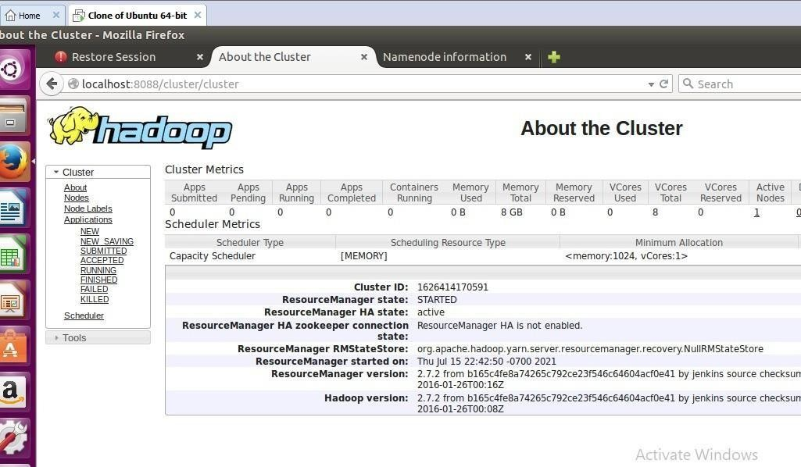

**EXP. 23: INSTALL HADOOP 2.X AND CONFIGURE THE NAME NODE AND DATANODE**. **Date**:21-09-2024

**AIM:** INSTALL HADOOP 2.X AND CONFIGURE THE NAME NODE AND DATANODE.

**Screenshots and Outputs:**

export JAVA_HOME=/usr/lib/jvm/java-8-oracle

export HADOOP_HOME=/usr/local/hadoop/hadoop-2.7.2 export PATH=$PATH:$HADOOP_HOME/bin

export PATH=$PATH:$HADOOP_HOME/sbin

export HADOOP_MAPRED_HOME=$HADOOP_HOME export HADOOP_COMMON_HOME=$HADOOP_HOME export HADOOP_HDFS_HOME=$HADOOP_HOME

export YARN_HOME=$HADOOP_HOME HADOOP_COMMON_LIB_NATIVE_DIR=$HADOOP_HOME/lib/native export HADOOP_OPTS="-D.java.library.path=$HADOOP_HOME/lib" export PATH=$PATH:/usr/local/hadoop/hadoop-2.7.2/bin

# The java implementation to use.

export JAVA_HOME=/usr/lib/jvm/java-8-oracle

<configuration>

<property>

<name>dfs.replication</name>

<value>1</value>

</property>

<property>

<name>dfs.namenode.name.dir</name>

<value>file:/usr/local/hadoop_tmp/hdfs/namenode</value>

</property>

<property>

<name>dfs.datanode.data.dir</name>

<value>file:/usr/local/hadoop_tmp/hdfs/datanode</value>

</property>

</configuration>

<configuration>

<property>

<name>fs.default.name</name>

<value>hdfs://localhost:9000</value>

</property>

</configuration>

<configuration>

<property>

<name>yarn.nodemanager.aux-services</name>

<value>mapreduce_shuffle</value>

</property>

<property>

<name>yarn.nodemanager.aux-services.mapreduce.shuffle.class</name>

<value>org.apache.hadoop.mapred.Shuffle-Handler</value>

</property>

</configuration>

<configuration>

<property>

<name>mapreduce.framework.name</name>

<value>yarn</value>

</property>

</configuration>

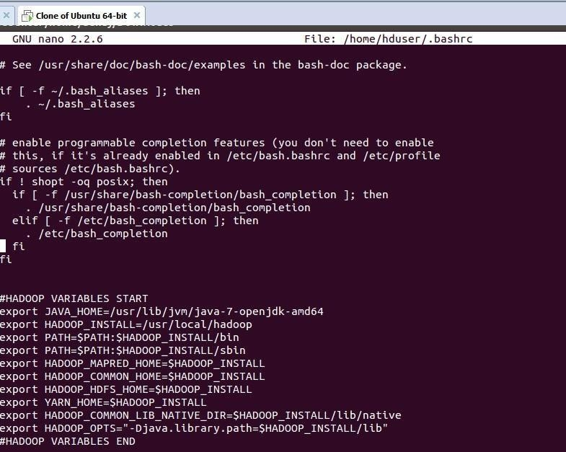

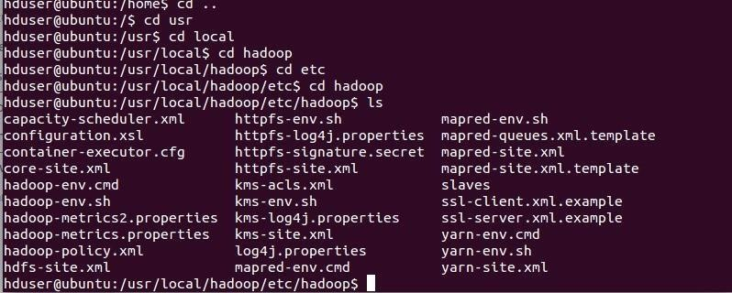

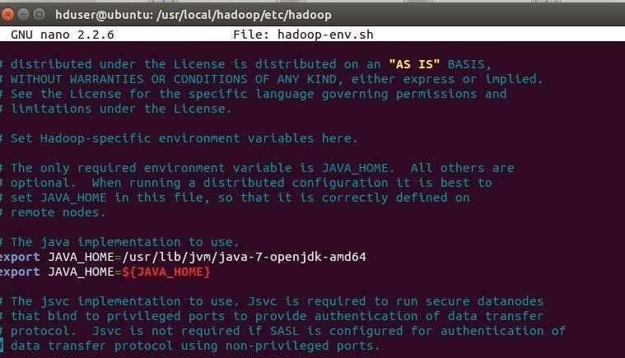

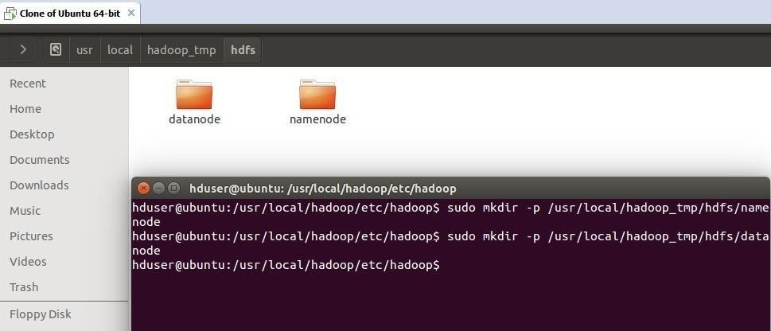

**EXP. 24:** LAUNCH THE HADOOP 2.X AND PERFORM MAPREDUCE PROGRAMFOR A WORD COUNT PROBLEM

**Date:**23-09-2024

**AIM:** LAUNCH THE HADOOP 2.X AND PERFORM MAPREDUCE PROGRAMFOR A WORD COUNT PROBLEM

**Screenshots and Outputs:**

import org.apache.hadoop.conf.Configured; import org.apache.hadoop.fs.Path;

import org.apache.hadoop.io.IntWritable;

import org.apache.hadoop.mapred.FileInputFormat; import org.apache.hadoop.mapred.FileOutputFormat;import org.apache.hadoop.mapred.JobClient;

import org.apache.hadoop.mapred.JobConf;

import org.apache.hadoop.util.Tool;

import org.apache.hadoop.util.ToolRunner; import org.apache.hadoop.io.Text;

public class WordCount extends Configured implements Tool {@Override public int run(String[] arg0) throws Exception {

// TODO Auto-generated method stubif(arg0.length<2)

{

}

}

import java.io.IOException;

import org.apache.hadoop.io.IntWritable; import org.apache.hadoop.io.LongWritable;

import org.apache.hadoop.mapred.MapReduceBase; import org.apache.hadoop.mapred.OutputCollector; import org.apache.hadoop.mapred.Reporter;

import org.apache.hadoop.io.Text;

import org.apache.hadoop.mapred.Mapper;

public class WordCountMapper extends MapReduceBase implements Mapper<LongWritable,Text,Text,IntWritable>

{

@Override

public void map(LongWritable arg0, Text arg1, OutputCollector<Text, IntWritable> arg2, Reporter arg3)

import java.io.IOException;import java.util.Iterator;

import org.apache.hadoop.io.IntWritable; import org.apache.hadoop.mapred.JobConf;

import org.apache.hadoop.mapred.OutputCollector; import org.apache.hadoop.mapred.Reducer;

import org.apache.hadoop.mapred.Reporter; import org.apache.hadoop.io.Text;

public class WordCountReducer implements Reducer<Text,IntWritable,Text,IntWritable> { @Override

public void configure(JobConf arg0) {

}

@Override

public void reduce(Text arg0, Iterator<IntWritable> arg1, OutputCollector<Text, IntWritable> arg2, Reporter arg3)

throws IOException {

// TODO Auto-generated method stubint count=0;

while(arg1.hasNext())

{

IntWritable i=arg1.next(); count+=i.get();

